A

PROJECT REPORT

ON

“Sai Auto Showroom”

(IN ASP.NET WITH C#)

**SUBMITED TO**

“SHIVAJI UNIVERSITY, KOLHAPUR”

BACHELORE OF COMPUTER APPLICATION –III

(SEMISTER - VI)

Mr.Bavachkar Rushikesh Popatrao.

Miss.Kamble Snehal Babaso.

Miss.Khot Priyanka Rajaram.

Miss.Patil Archana Sanjay.

**UNDER THE VALUABLE GUIDENCE OF**

Miss.Patil.M.S.



**THOUGHT THE**

DEPARTMENT OF COMPUTER

Kasegaon Education Society’s

ART’S & COMMERCE COLLEGE, ASHTA.

Year2020-2021

**Kasegaon Education Society’s**

Art,s and Commerce College, Ashta

**Department of Computer**



**Certificate**

This is to certify that **Mr.Bavachkar Rushikesh Popatrao**, **Miss.Kamble Snehal Babaso,Miss.Khot Priyanka Rajaram, Miss.Patil Archana Sanjay.** Are the confide students of this college studding in BCA III (Sem-VI) during the year 2020-2021. They have satisfactorily completed their work titled “VEHICLE SHOWROOM” in ASP.Net with C#.

Their project work show their hard work &sincere efforts.

**Project Guide H.O.D. Principal Examiner**

**Miss. Patil M.S. Mr. Desavale A.H. Mr.Kurlupkar.R.M.**

**Date:**

**Place: Ashta**

**Declaration**

To,

The principal,

Art’s & commerce college, Ashta.

Respected Sir,

We undersigned here by Mr.Bavachkar Rushikesh Popatrao, Miss.Kamble Snehal Babaso,Miss.Khot Priyanka Rajaram, Miss.Patil Archana Sanjay. I declare that the project report on “Sai Auto Showroom Management System” submitted by under guidance of Mrs. Patil M.S. is our original work.

We have not reproduced any information from any report submitted by to Shivaji University Kolhapur this year or any of the previous years.

We understand that any such copying is liable to be punished in a way the university authority may be deem fit.

**Date:**

**Place: Ashta.**

**Student Name Sign**

**Mr.Bavachkar Rushikesh Popatrao.**

**Miss.Kamble Snehal Babaso.**

**Miss.Khot Priyanka Rajaram.**

**Miss.Patil Archana Sanjay.**

**Acknowledgement**

This is our great pleasure to submitted this project report titled “**Sai Auto Showroom**” to “Shivaji University, Kolhapur”. It is movement of great satisfaction pleasure gratitude for us to give heartly thanks to those help us to complete this project successfully in time.

We are heartly thankful to principle. **Dr.Kurlupkar.R.M.** in principle of Art’s & commerce college, Ashta. For providing us guidance regarding University rules and regulation for completing to study “**Bachelor of Computer Application**”.

We are also thankful to Mr.Desavale A.H. Head of Department of Computer. Also we would like to take this opportunity to than our lectures as well as project guide Mrs. Patil M.S. for her timely encouragement, proper guidance & suggestion to complete this project work in time. Also we are thankful tour all library staff for allowing us library facility time to time.

We would fail our duty if do not record our heartful thanks to our parents for inspiring, constant encouragement & construction criticism throughout the period of this project work.

**Student Name Roll No.**

**Mr.Bavachkar Rushikesh Popatrao.**

**Miss.Kamble Snehal Babaso.**

**Miss.Khot Priyanka Rajaram.**

**Miss.Patil Archana Sanjay.**

**Date:**

**Place: Ashta.**

**INDEX**

|  |  |
| --- | --- |
| **Sr. No** | **Contents** |
| Chapter1 | 1.**Introduction to project**   * Introduction * Existing system * Need of proposed system * Organization profile |
| Chapter 2 | 1. **Proposed system**  * Objective * Requirement Engineering * Requirement Gathering * SRS |
| Chapter 3 | **System Analysis**   * Data flow Diagrams |
| Chapter 4 | **User Manual** |
| Chapter 5 | **System Design**   * Database Design * Input Design |
| Chapter 6 | **Implementation**  System Requirement   * Hardware * Software * Installation process * User Guideline |
| Chapter 7 | **Conclusion & suggestion**   * Conclusion * Limitation * Suggestion |
| Chapter 8 | **Bibliography** |

**Introduction**

Every computer System is always useful to reducing the manual work. Same way the new computerized system for "Sai Auto Showroom" is also very useful for person who is operating this system. All the working daily information is stored manually this big book. They are using the registers for this purpose. This work is very ambiguous as they need to store each & everything by hand..

This system is reducing the work of updating race Deleting records, and Inserting records in database. All these functions are very important in the " Sai Auto Showroom",

All these function are done by automatically with the help of this system in this system there are mainly four functions like Submit, Delete and update data. The submit function is used to adding new records & save it. The delete function is used to deleting the records from the database. The update function is used to updating the records from the database. Maintaining all the record & getting in few seconds. Thus, time consuming work is reduces. It is easier to maintain such necessary things. There are more changes of mistakes in proper work, if provided that all the material correct. It can be seen that the today world is fatly moving on the computerized work. The old traditional method of maintaining the records or completing the work using the paper source is fatly diminishing & is being replaced by the computers. The main reasons behind this were the time required for processing the data, maintaining it & so on. All these problems were easily solved due to computerization. The registration is also and oldest method required to use widely and compulsorily but required a lot of time to complete it with paper work. Thus the concept is brought into exist

**Introduction To ASP**

ASP stands for Active Server Pages ASP is a relatively new technology that has already leapt through several stages of evolution. It was introduced about 5 years ago as an easy way to add dynamic content to ordinary web pages. Since then, it's quickly transformed into: something entirely different: a platform for creating advanced web application, including E-commerce shop, data-driven portal sites, & just about anything else you can find on the internet.

As a result of these transformations, ASP developed have become experts in compromise. They've created innovative solution using custom components, include files & other tricks in order to manage the tangle of scripting code & provide advanced features the .NET platform promises to change all that. The drawback is the fairy serious learning curve involved in mastering for web application from the ground up. It's well planned, well organized, & easier to learn than traditional ASP. It's also stuffed full of prebuilt functionality that can make many common tasks effortless.

**Tools Information**

* **Standard Control:-**

**1] Button:-**

This control creates the familiar clickable push button on Web pages.

**2] Image:-**

This control displays an image (Typically a jpg).

**3] Image Button:-**

This control is almost identical to the image control. Click event when the user clicks it.

**4] Label:-**

This control represents ordinary text on webpage.

**5] Table:-**

This control represents a table with rows & columns.

**6] Text Box:-**

This control represents a text box where the user can enter the information.

**7] List Box:-**

This control displays a list of items.

**8] Drop Down List:-**

This control represents a drop-down single-selected list.

* **Validation Control:-**

The validation controls were introduced in validation and rich controls as a powerful way to user input & display custom error messages. The validation controls come in 5 separate versions. each on tailored to perform the different types of validation.

**I]** Custom Validator.

**II]** Compare Validator.

**III]** Range Validator.

**IV]** Regular Expression Validator.

**V]** Required Field Validator.

1. **Custom Validator:-**

The custom Validator perform validation at the server side by responding to the server validate event in addition you can specify a client side validation function that will prevent the page from being posted back when an error is countered.

1. **Compare Validator:-**

This control compares the value in one input control with the value in another. The type of comparison depends on the operator property.

1. **Range Validator:-**

The control checks whether a given value in an input control matches a set value or false within a predefined range.

1. **Regular Expression Validator:-**

These Control checks whether user - entered value matches a specified regular expression.

1. **Required Field Validator:-**

This control checks whether a user has entered a value in a given control. This Validator is option used in conjunction with other validation controls because all other controls will automatically skip their validation if file an empty value.

* **Data Control:-**

1. **Grid View:-**

Display the Data.

1. **Sql Data Source:-**

Record display with Insert, Delete & Update.

* **Navigation Control:-**

1. **Menu:-**

Display the multiple link menus.

1. **Tree View:-**

Display the multiple links.]

**Existing System**

It is important to manage daily transactions such as order, sales, purchase, and delivery of ordered items in showroom system. In manual system, people have to perform all these transactions by manually using papers. Manual system does not maintain paper records for long period of time and also it requires large space.

It is very tedious work to check the papers of transactions and their reports. Also it requires large main power as compared to existing system. Keeping records of all the daily transactions manually is very time consuming job. It cannot store data permanently as compare to computer system. To overcome these problems, the existing computerized system "Sai Auto Showroom Management System " is designed. This system is easy to handle and is more user friendly as compared to traditional systems. It can easily handle day-to-day operations in factory i.e. placing order. delivery of order. sales and purchase.

It keeps records of all the daily transactions. Also it keeps records of customers, suppliers and worker available in bazaar. It requires few man powers as compared to traditional systems. To avoid the problems with traditional system, the existing system "Sai Auto Showroom Management System" is designed.

**NEED AND SCOPE FOR COMPUTER**

**SYSTEM:-**

**NEED FOR NEW SYSTEM**

There is need of computerized system as we have to overcome the drawback of

Manual system. The need are as follows:

**Computerization saves manpower and time:-**

For instance lot of time is wasted in writing same record again and again in this process of renewing the data hence a lot of man power is wasted in manual work.

But in case of computerized one can do all the things mentioned above easily with a single click of the computer button and only man require.

Hence, computerization reduces manpower and time.

**Accuracy and Efficiency:-**

Computers are very accurate so that the records of any computer can be easily searched and the data can be modified within few seconds and hence it improves the working capacity.

**Large Storage Capacity:-**

There is no need of maintaining such huge registers for data storage since computer store a large amount of data at a large amount of data at a time.

**Instant Report Generation:-**

Due to computerization the queries of the managers can be answered quickly due to generation of different types of reports.

**Reduced Calculation:-**

While working manually employee has to make calculation, keep records, calculate various sums etc. This can be reduced with the help of computerization.

If we take into consideration all the factors or drawback then become necessary to develop software, which can have a central control over all the process. By develop software, which can have a software one can provide password for the safe of security. The auto generation of registration number will help to reduce time in typing the same data, which should be transferred from one to other.

**ADVANTAGES OF COMPUTERIZATION**

* As the system comprise various forms, it is easy to handle transaction interaction.
* Due to computerization searching the records is very easy.
* Repetition of records is not required. It provides security to the database system to protect the data and related records.
* Large amount of data can be stored for long duration.
* The computerized system saves the man power which is required to keep all records & saves time also.

**OBJECTIVES**

Objectives are the goal to achieve by using the system. Hence every system is proposed to achieve one or more objectives. The main objective of computerized system is not only to cover limitations left by manual system but also to give interactive facilities.

The main objectives of system are to overcome some or all problems that come during manual system.

To maintain correct and quick processing.

* To reduce manpower. required for generating result.
* Provide the security, authority, features and privacy.
* It can maintain high amount of data.
* To achieve accurate and quick processing of data for calculating results of function.
* It avoids replication of data particular required result.
* Most important things is customer get relaxation and satisfaction with it.

**REQUIREMENT ENGINEERING**

The phases from requirement analysis & specification to the testing are known as development Phases.

1. **Feasibility Analysis:-**

Analyzing the technical and economic feasibility of software

1. **Requirement Analysis & Specification :-**

Gathering and understanding the information from the customer and documenting the information for the software development.

1. **Design:-**

Translating the requirement from the software requirement specification into a structural from computable with the programming language

1. **Coding And Unit Testing :-**

Translating the functional specification of the design document in to a machine retable programming language & test each page of the program.

1. **Integration and system testing:-**

Collecting all the programs and conducting test on them to uncover error and bugs in the software product.

1. **Maintenances :-**

Removing the defects and adding software enhancement as specified by the Customer.

**SOFTWARE REQUIREMEMT SPECIFICATION (SRS)**

**SRS has four components,**

1] Functional requirement

2] Performance requirement

3] Design constraint requirement

4] External interface requirement

1. **Functional requirement:-**

It specifies which output should be produced from the given input. They describe the relationship between the input output system for the functional requirement for detail description of all data input and there source, the unit of measure and the range of valid input must be specifies this includes specifying the validity check on the input and output data.

This part of SRS specifies the system behavior in a normal situation like invalid input or error during computation the functional must the really state what the system should do if such situation occurs.

1. **Performance Requirement:-**

This part of SRS specifies the performance contain of on the software system there are two type of performance.

1. **Static**
2. **Dynamic**
3. **Static:-**

Static requirement are though that does not impose contain on the execution characteristics of the system.

1. **Dynamic:-**

Dynamic requirement specifies contents on the execution behavior of the system this include responses time, the responses time is expected time the completion of an operation under specified circumstance.

1. **Design constraint requirement :-**

An SRS should identify and specify all following contains.

1. **Standard compliance**
2. **Hardware limitation**
3. **Security**
4. **Standard compliance:-**

This specify the requirement for the I the system must follow the standard may include the report format and accounting procedures.

1. **Hardware limitation**:-

Hardware limitation include the type of machine to be used operating system available on the system, language supported and limits on primary and secondary storage.

1. **Security:-**

Security requirement are particularly significantly in depends system and many database system. Security requirement place restriction on the use of certain commands, control access to data provide different kind of access requirement for different people require the use of password and cryptographic technique and maintain login of activity in the system.

1. **External interface requirement :-**

All the interconnection of the software with hardware should be clearly specifies for the use interface the characteristic of cash user interface of the software products should be specified user interface is becoming sincerely important and must be given proper attention.

**CONTEXT LEVEL DIAGRAM**

The context level DFD is also known as zero level DFD. In this there are two entities are present that are Customer and Administrator. Customer gives the input to the system as per requirement that means. Since it is window based system each time the customer needs to interact with Administrator.

**DFD (Context Level Diagram):-**

Sale

Purchase

Sale Gives

Detail Bill Detail

Quotation Details Gives Stock Detail

Customer Details

Administrator

Customer

Booking Details Quotation report

Bill Paid Purchase Gives

Detail Bill Detail

Gives Order

**DATA FLOW DIAGRAM (DFD)**

DFD is process modeling tool used during problem of analysis. DFD is graphical representation of data moment, process and file used in support of information system.

Request for LoginCheck for Login

Admin

**Admin**

Response Reply

Add Supplier Information Save Data

Supplier Info

Supplier

Information

Response Reply

Add Stock save Data

Stk

Stock

Response Reply

Add Worker Information Save Data

Worker Info

Worker Information

Response Reply

Add Worker Salary Save Data

Worker Salary

Worker

Salary

Response Reply

Report

Request for LoginCheck for Login

Userhome

**Userhome**

Response Reply

Add Customer Information Save Data

Customer Info

Customer Information

Response Reply

Add Customer Bill Form save Data

Customer Bill Form

Customer Bill

Response Reply

Add Booking Order Save Data

Worker Info

Booking Order

Response Reply

**ENTITY RELATIONSHIP DIAGRAM (ERD)**

ER-Diagram is represents graphical representation of entities and relationship between them. ER-Diagram is really important for understanding flow of data within system.

**Entity:**

An Entity is a business object which is represents a group of data

**Attribute:**

An Attribute is a Sub-group of information/data within Entity.

Worker Salary

Worker Info

Worker

Booking

has

Customer Info

Customer Bill

has

Stock

Supplier Info

Generate

Admin

Customer

Supplier Bill

Generate

User

**USER MANUAL**

The Visual studio is used to design software. The system has various from that user to use the system. The has various webpage’s that are following mentioned.

All below listed menus are appearing on main menu screen.

To select/choose the menus you can use clicking method and appropriate shortcut key.

* **Admin login:-**

* + - Supplier Information
    - Stock
    - Worker Information
    - Worker Salary
    - Report
    - Home
* **User login:-**
  + - * Customer Information
      * Customer Bill Form
      * Booking Order
      * Supplier Bill Form
      * Product List
      * Contact Us
      * Home

**Database Design**

**Customer Bill:-**

|  |  |  |
| --- | --- | --- |
| **Sr.No** | **Column Name** | **Data Type** |
| 1 | Customer_Id | Int |
| 2 | Customer_Name | varchar(50) |
| 3 | Address | varchar(50) |
| 4 | Model_Type | varchar(50) |
| 5 | Model_Name_Color | varchar(50) |
| 6 | Engine_No | Numeric(18, 0) |
| 7 | Chassis_No | Numeric(18, 0) |
| 8 | Price | Numeric(18, 0) |
| 9 | Quantity | Numeric(18, 0) |
| 10 | Insurance | Numeric(18, 0) |
| 11 | GST | Numeric(18, 0) |
| 12 | Accessary_Charge | Numeric(18, 0) |
| 13 | Total_Price | Numeric(18, 0) |
| 14 | Payment_Method | varchar(50) |
| 15 | Card_No | Numeric(18, 0) |
| 16 | CVV | Numeric(18, 0) |
| 17 | Date | Date |

**Customer Booking:-**

|  |  |  |
| --- | --- | --- |
| **Sr.No** | **Column Name** | **Data Type** |
| 1 | Customer_Id | Int |
| 2 | Customer_Name | varchar(50) |
| 3 | Address | varchar(50) |
| 4 | Mob_No | Numeric(18, 0) |
| 5 | Model_Type | varchar(50) |
| 6 | Model_Name_Color | varchar(50) |
| 7 | Price | Numeric(18, 0) |
| 8 | Model_ No | Numeric(18, 0) |
| 9 | Addvance | Numeric(18, 0) |
| 10 | Payment_Method | varchar(50) |
| 11 | Card_No | Numeric(18, 0) |
| 12 | CVV | Numeric(18, 0) |
| 13 | Booking_Date | Date |

**Customer Info:-**

|  |  |  |
| --- | --- | --- |
| **Sr.No** | **Column Name** | **Data Type** |
| 1 | Customer_Id | Int |
| 2 | Customer_Name | varchar(50) |
| 3 | Address | varchar(50) |
| 4 | Pin_code | Numeric(18, 0) |
| 5 | Mob_No | Numeric(18, 0) |
| 6 | Email_Id | varchar(50) |
| 7 | Date | Date |

**Stock:-**

|  |  |  |
| --- | --- | --- |
| **Sr.No** | **Column Name** | **Data Type** |
| 1 | Model_ID | Int |
| 2 | Model_Type | varchar(50) |
| 3 | Model_Name_Color | varchar(50) |
| 4 | Price | Numeric(18, 0) |
| 5 | Old_stock | Numeric(18, 0) |
| 6 | Purchase_quantity | Numeric(18, 0) |
| 7 | Total_stock | Numeric(18, 0) |
| 8 | Purchase_Date | Date |

**Supplier Bill Form:-**

|  |  |  |
| --- | --- | --- |
| **Sr.No** | **Column Name** | **Data Type** |
| 1 | Supplier _ID | Int |
| 2 | Supplier_Name | varchar(50) |
| 3 | Address | varchar(50) |
| 4 | Mob_No | Numeric(18, 0) |
| 5 | Old_stock | Numeric(18, 0) |
| 6 | Model_Type | varchar(50) |
| 7 | Model_Name_Color | varchar(50) |
| 8 | Price | Numeric(18, 0) |
| 9 | Quantity | Numeric(18, 0) |
| 10 | Total_Price | Numeric(18, 0) |
| 11 | Payment_Method | varchar(50) |
| 12 | Card_No | Numeric(18, 0) |
| 13 | CVV | Numeric(18, 0) |
| 14 | Date | Date |

**Supplier Info:-**

|  |  |  |
| --- | --- | --- |
| **Sr.No** | **Column Name** | **Data Type** |
| 1 | Supplier_Id | Int |
| 2 | Supplier_Name | varchar(50) |
| 3 | Address | varchar(50) |
| 4 | Pin_code | Numeric(18, 0) |
| 5 | Mob_No | Numeric(18, 0) |
| 6 | Email_Id | varchar(50) |
| 7 | Date | Date |

**Worker Info:-**

|  |  |  |
| --- | --- | --- |
| **Sr.No** | **Column Name** | **Data Type** |
| 1 | Worker_Id | Int |
| 2 | Worker_Type | varchar(50) |
| 3 | Worker_Name | varchar(50) |
| 4 | Address | varchar(50) |
| 5 | Mob_No | Numeric(18, 0) |
| 6 | Email_Id | Numeric(18, 0) |
| 7 | Joining_Date | Date |
| 8 | Basic_Salary | Numeric(18, 0) |
| 9 | Per_Day_Salary | Numeric(18, 0) |
| 10 | Ref_Name | varchar(50) |
| 11 | Ref_Mobile_No | Numeric(18, 0) |
| 12 | Account_No | Numeric(18, 0) |

**Worker Salary:-**

|  |  |  |
| --- | --- | --- |
| **Sr.No** | **Column Name** | **Data Type** |
| 1 | Worker_Id | Int |
| 2 | Worker_Type | varchar(50) |
| 3 | Worker_Name | varchar(50) |
| 4 | Per_Day_Salary | Numeric(18, 0) |
| 5 | Attendance_Day | Numeric(18, 0) |
| 6 | OverTime | Numeric(18, 0) |
| 7 | Total_Salary | Numeric(18, 0) |
| 8 | Account_No | Numeric(18, 0) |
| 9 | Salary_Date | Date |

**Input Design**

**Admin**

* **Admin Login:-**

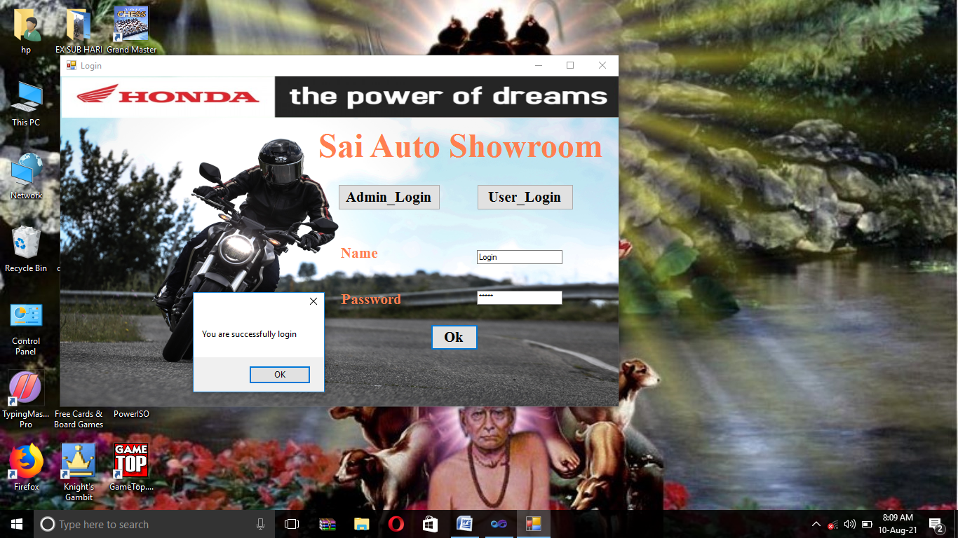

* **Admin Home:-**

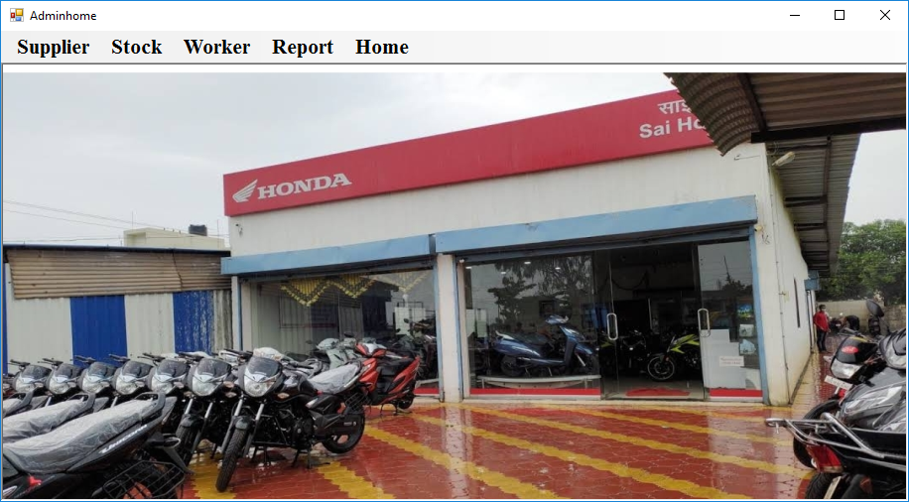

* **Supplier Information:-**

**Submit:-**

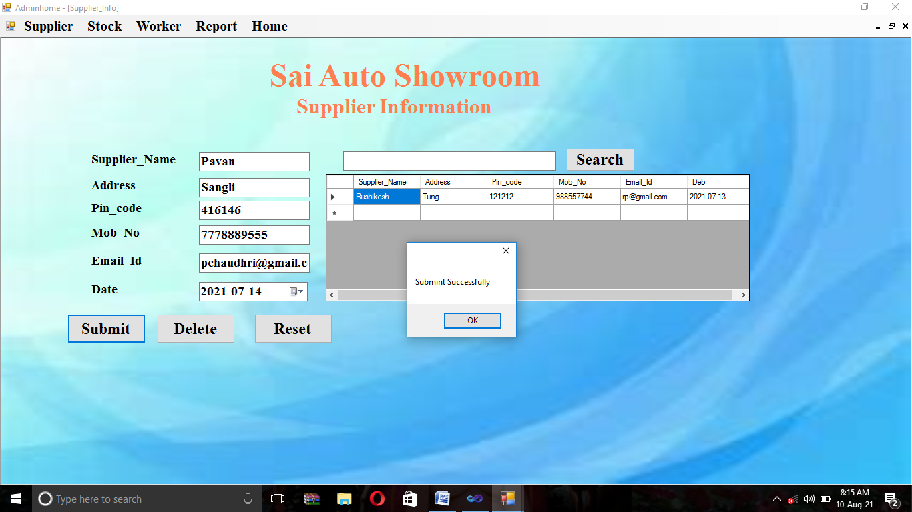

**Update:-**

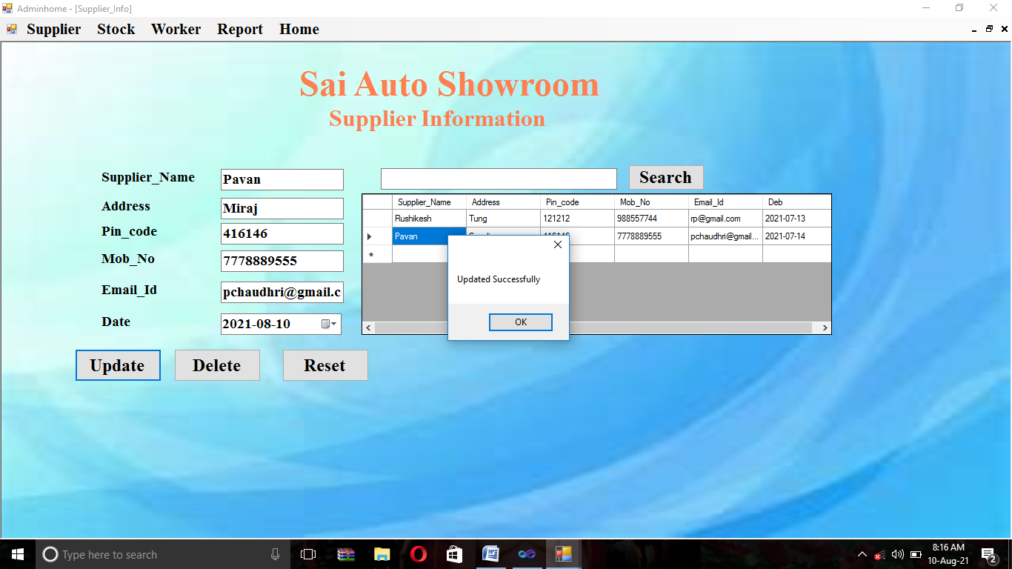

**Delete:-**

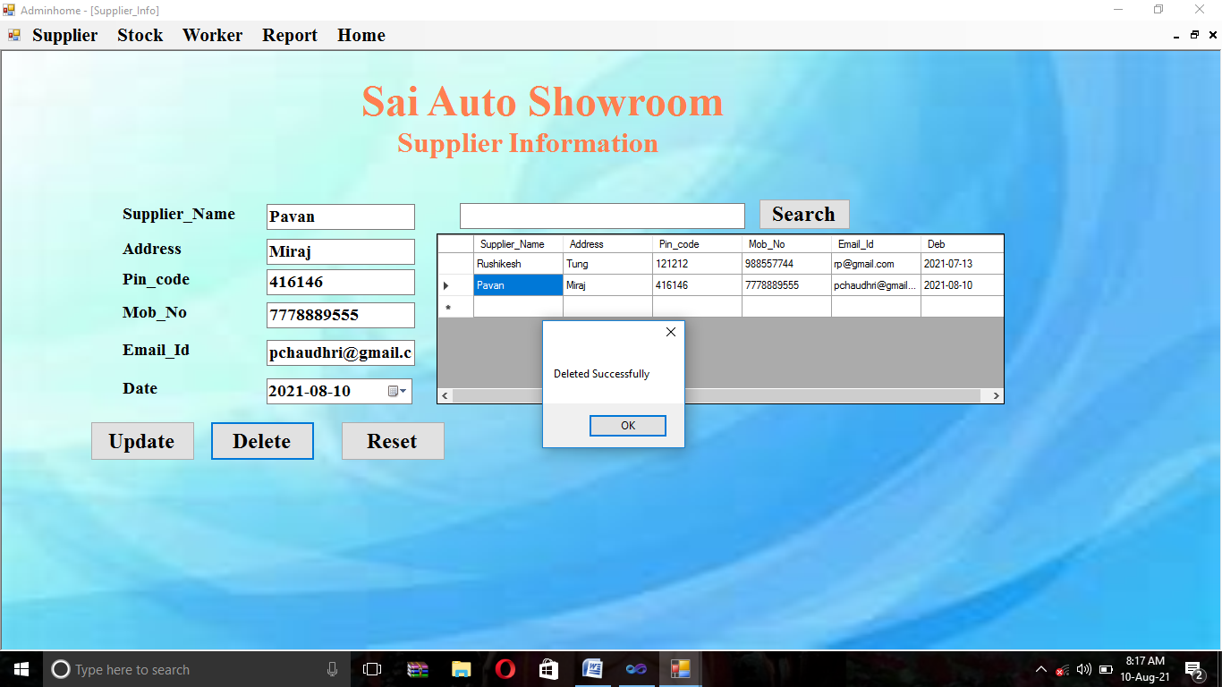

**Search:-**

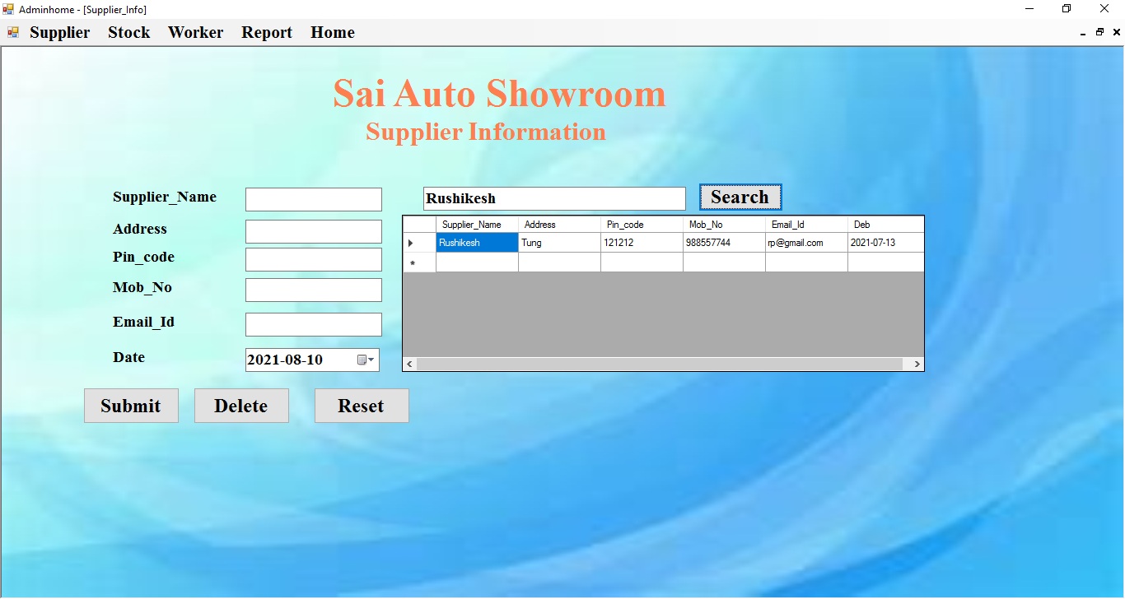

* **Stock:-**

**Submit:-**

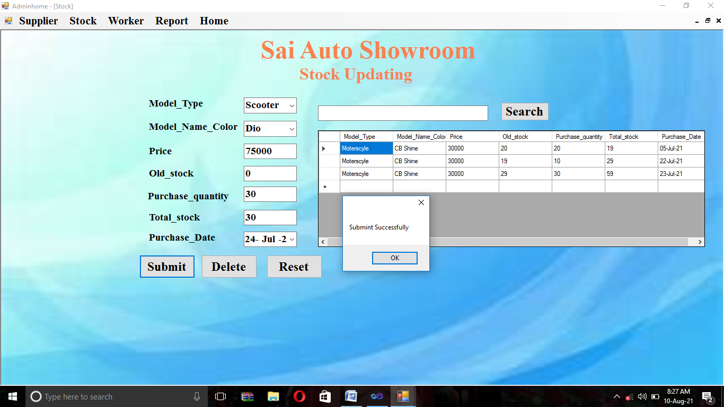

**Update:-**

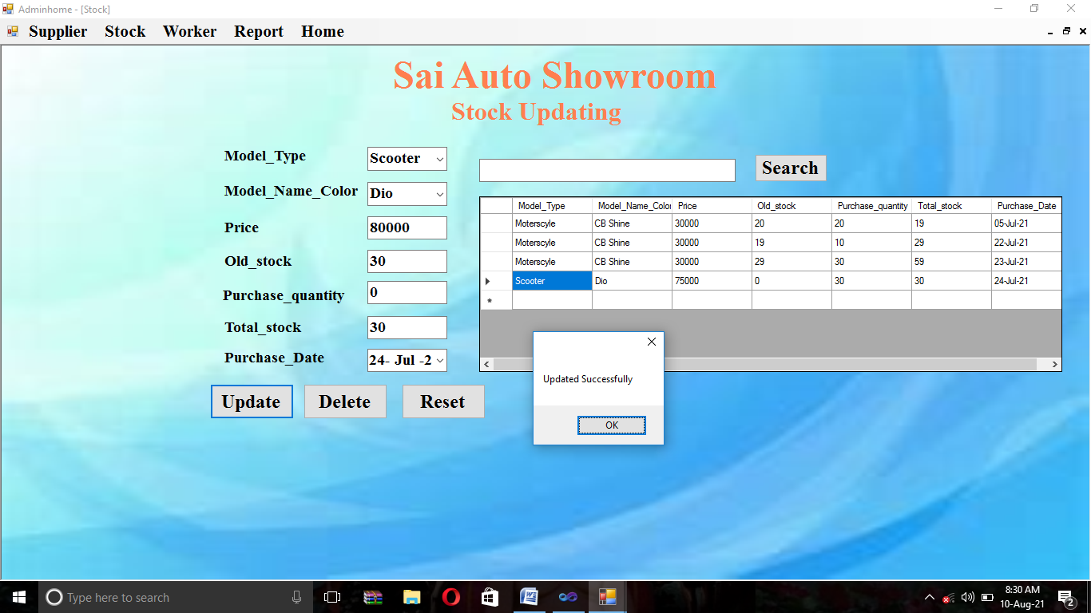

**Delete:-**

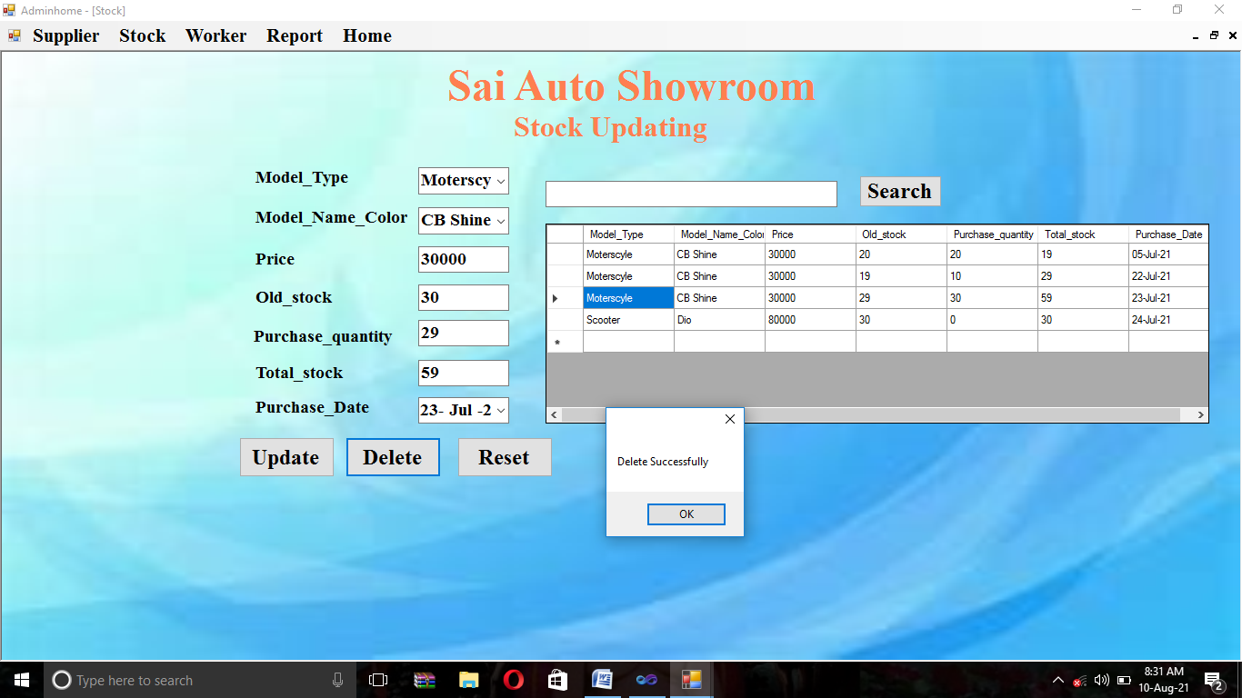

**Search:-**

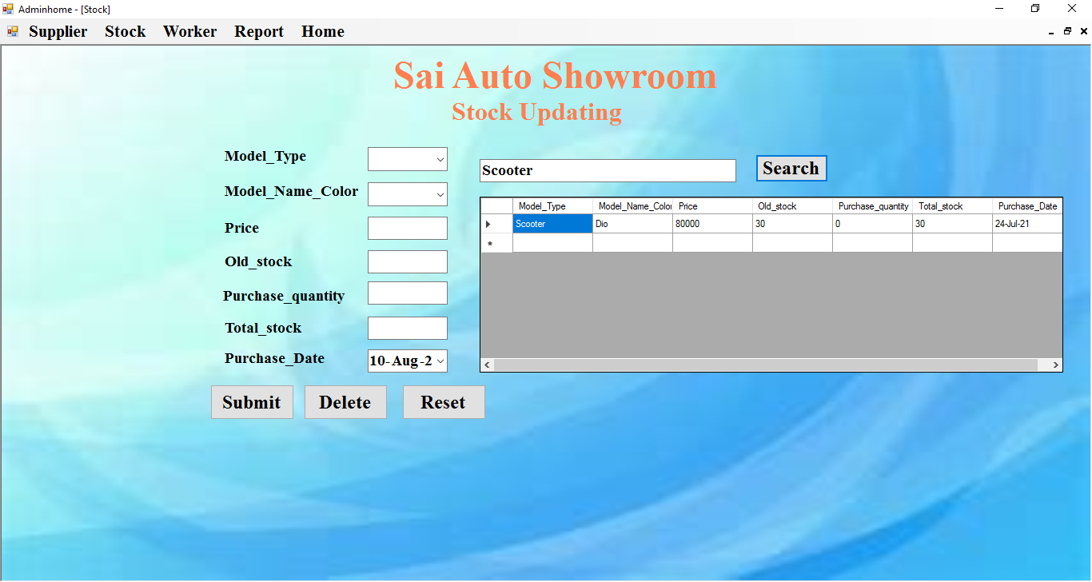

* **Worker Information:-**

**Submit:-**

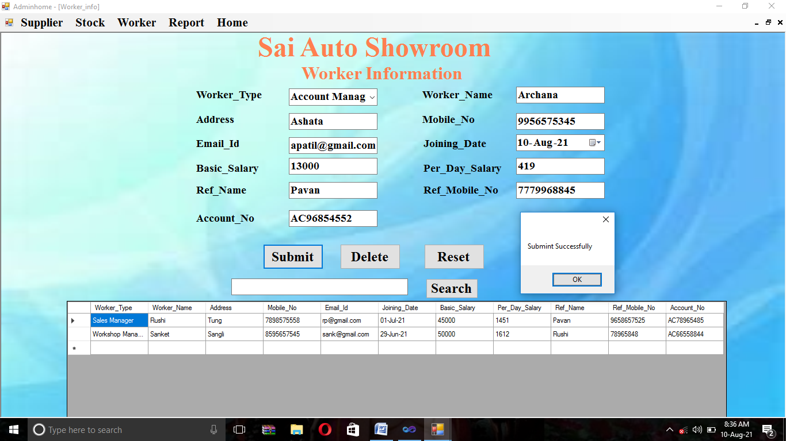

**Update:-**

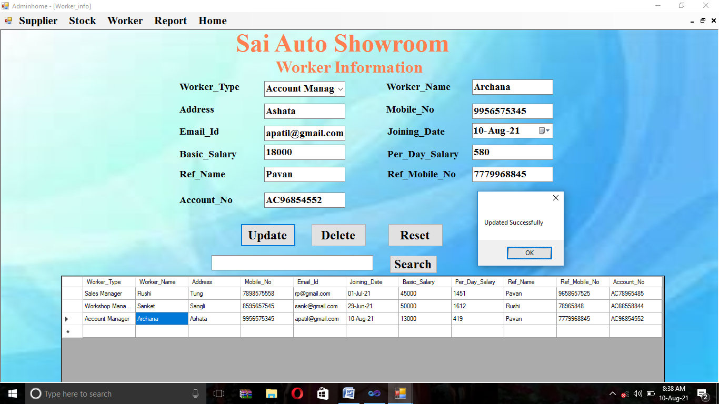

**Delete:-**

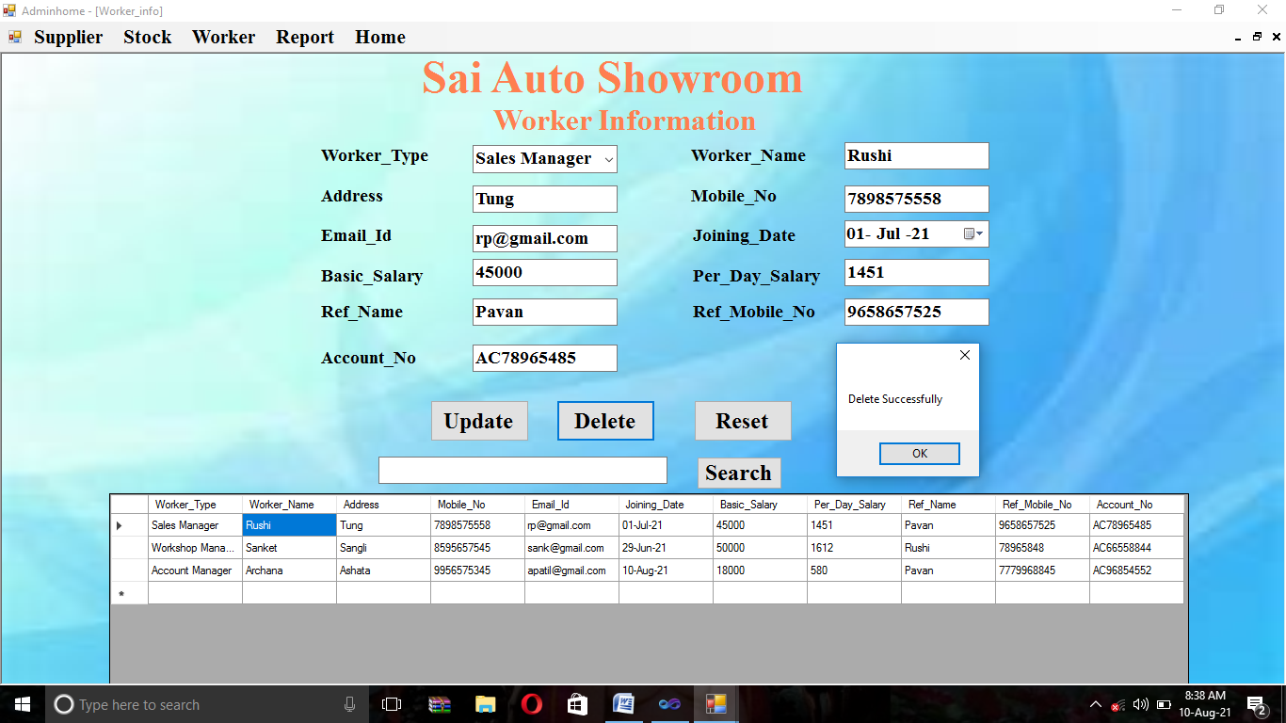

**Search:-**

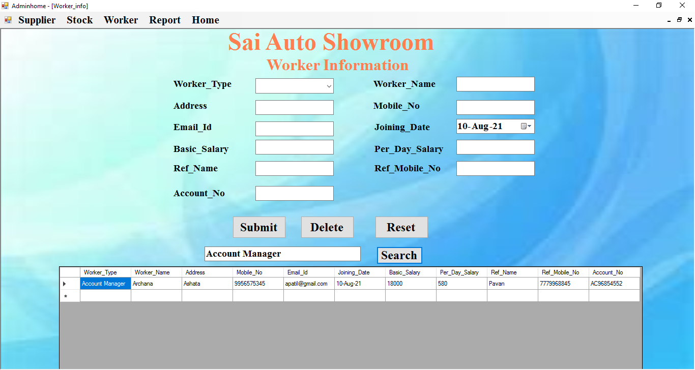

* **Worker Salary:-**

**Submit:-**

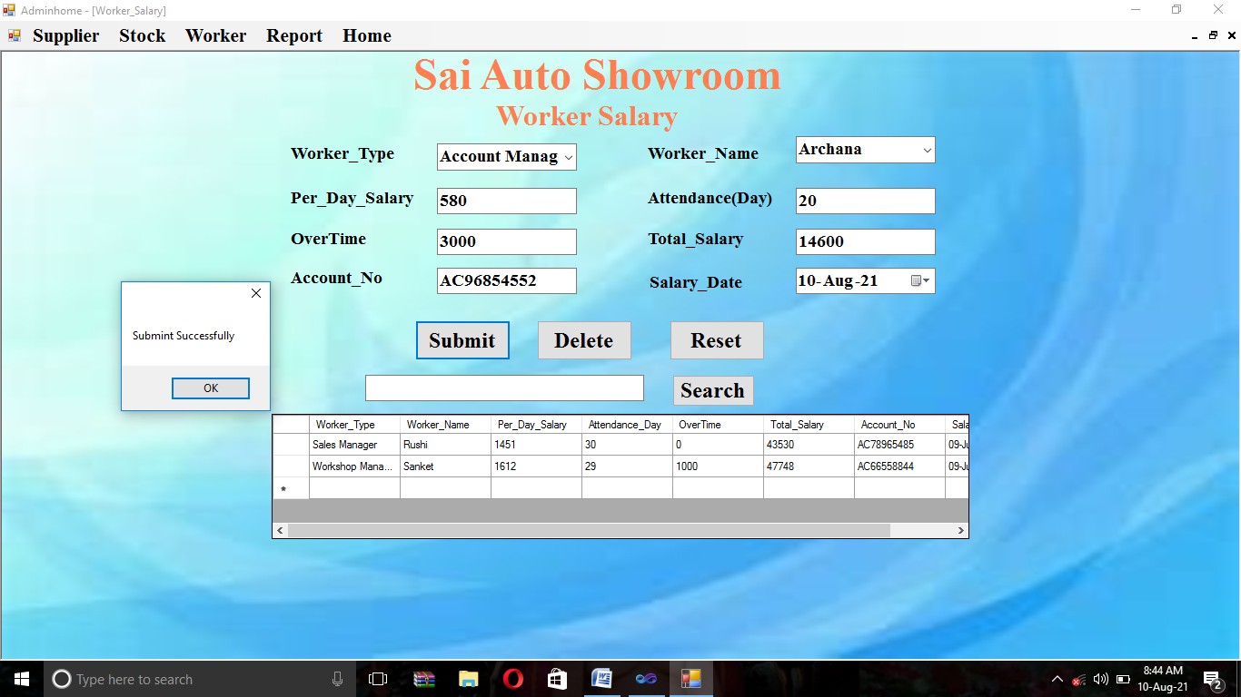

**Update:-**

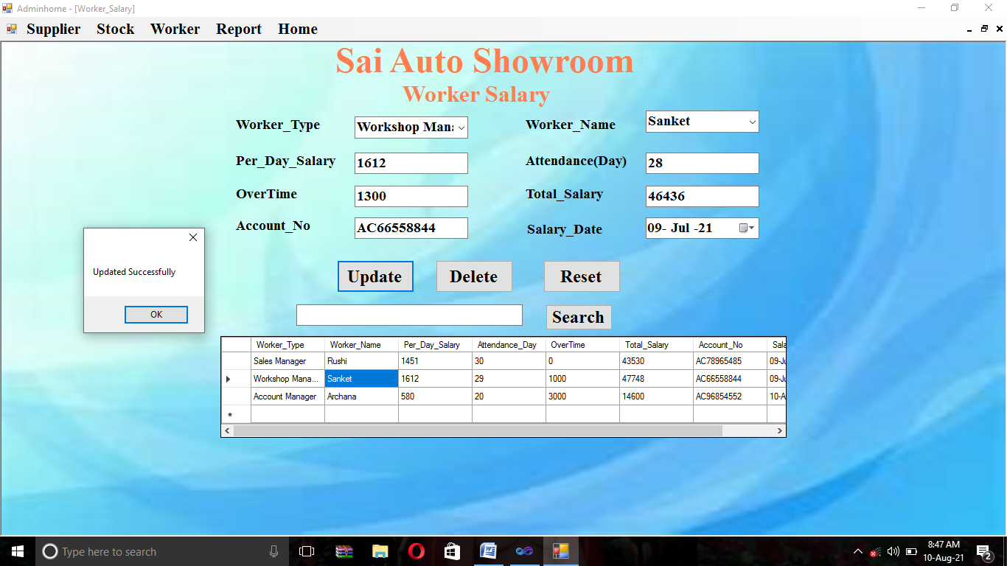

**Delete:-**

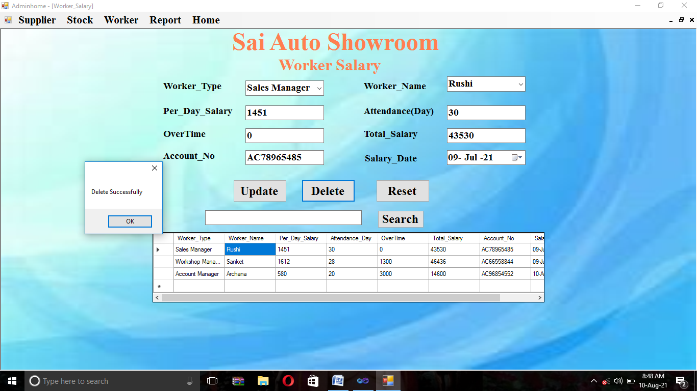

**Search:-**

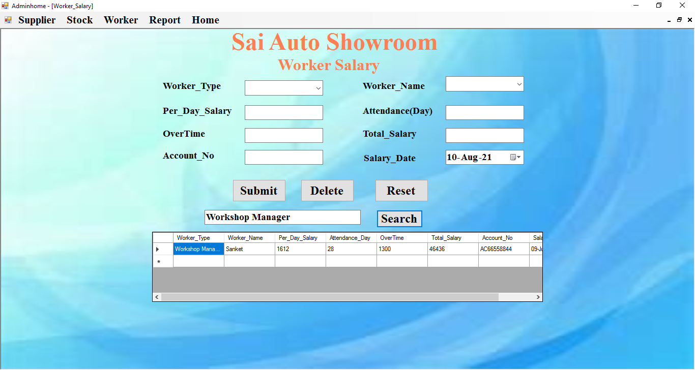

* **Report:-**
* **Simple Report:-**

**Customer Information:-**

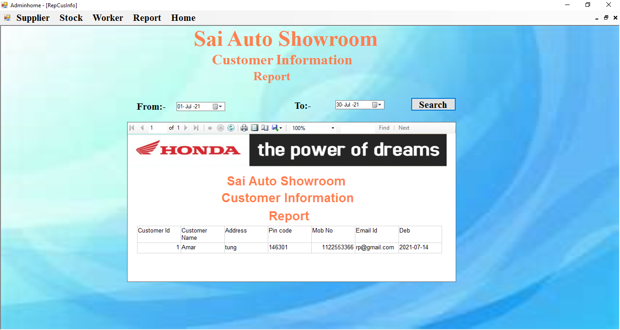

**Customer Bill:-**

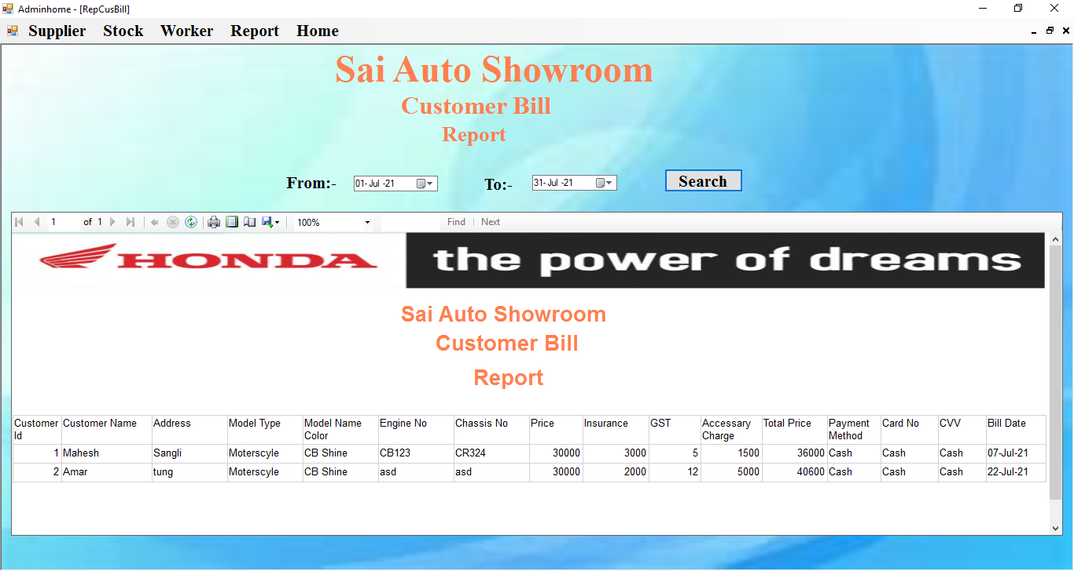

**Supplier Information:-**

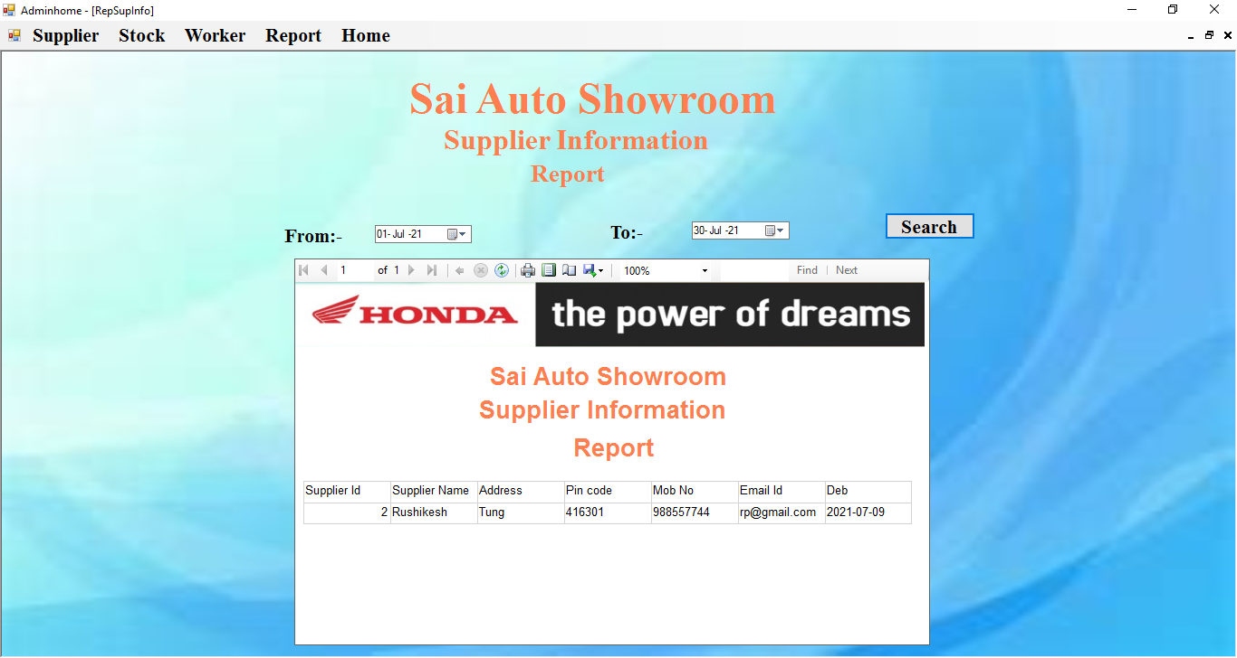

**Supplier Bill:-**

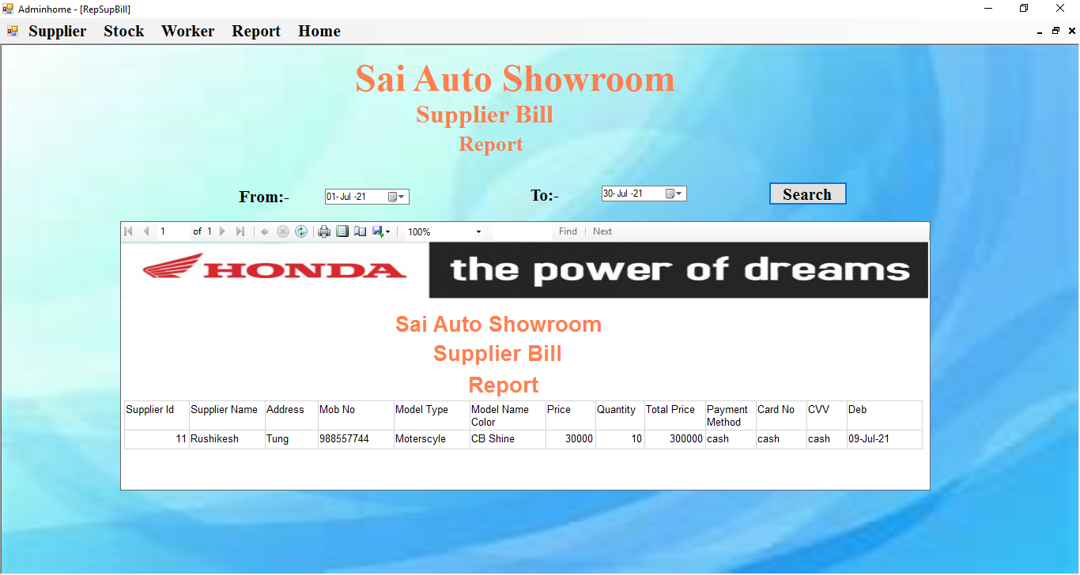

**Customer Booking:-**

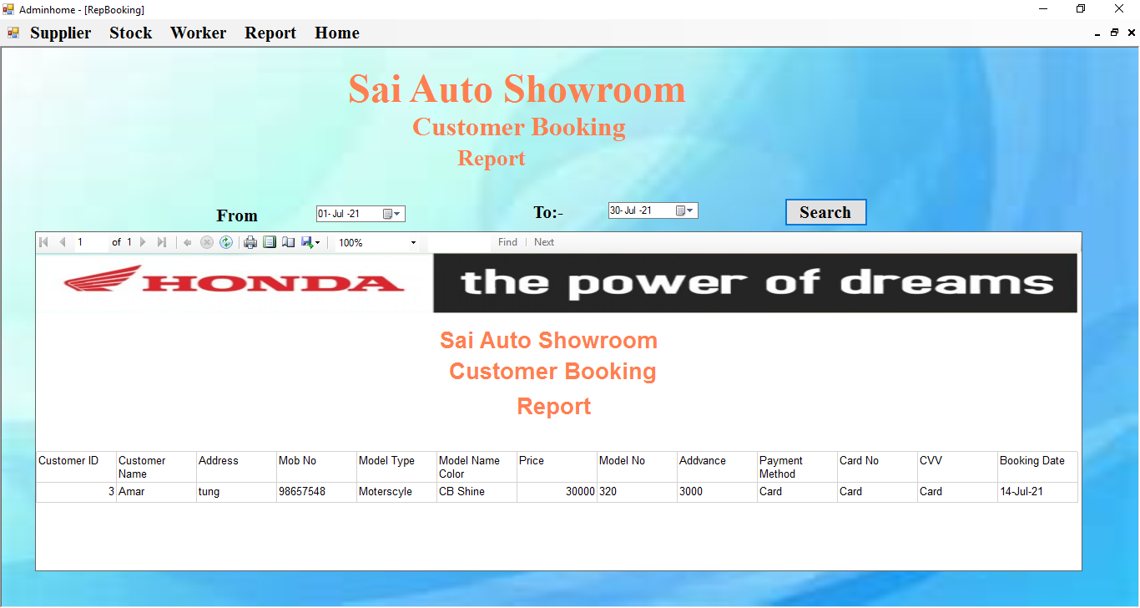

**Worker Information:-**

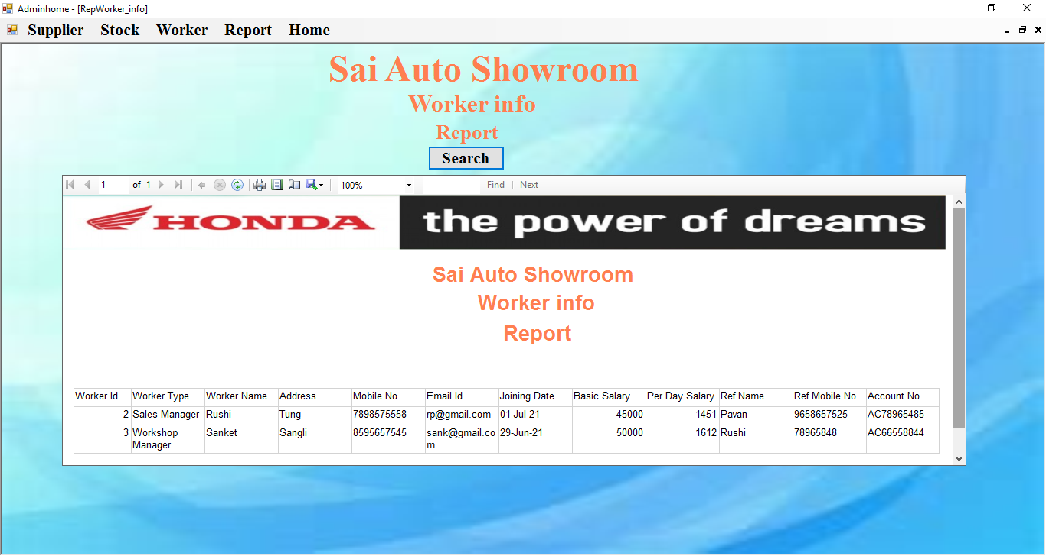

**Worker Salary:-**

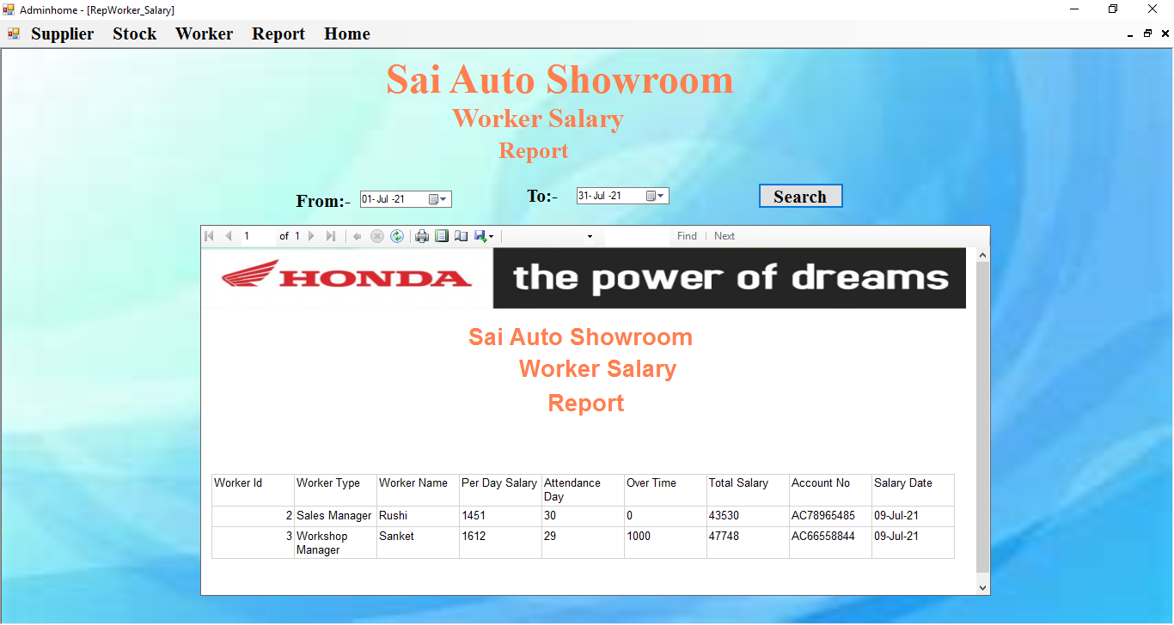

* **Monthly Report:-**

**Stock:-**

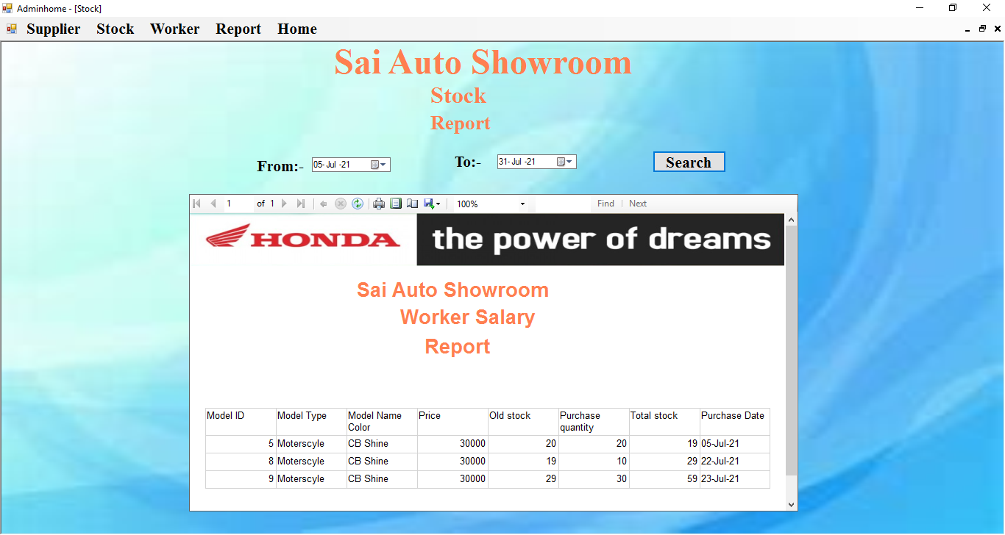

**Input Design**

**User**

* **User Login:-**

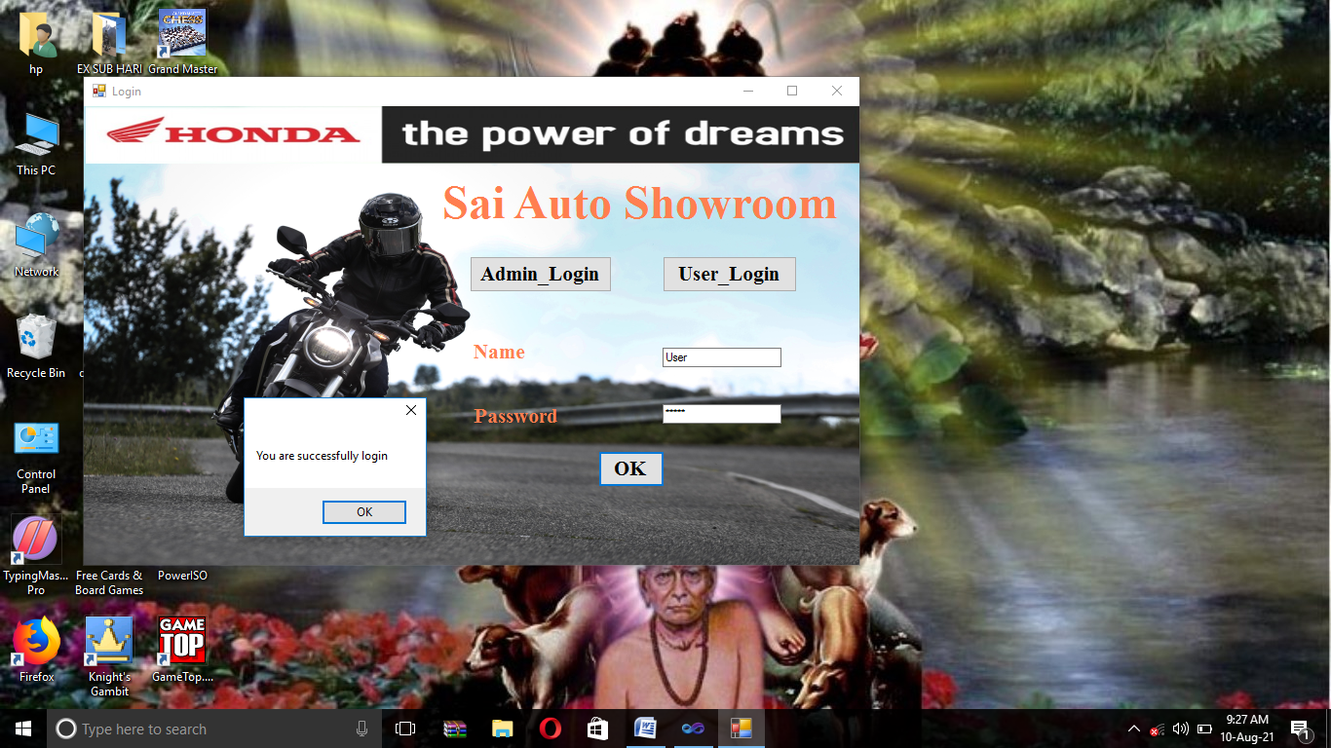

* **User Home:-**

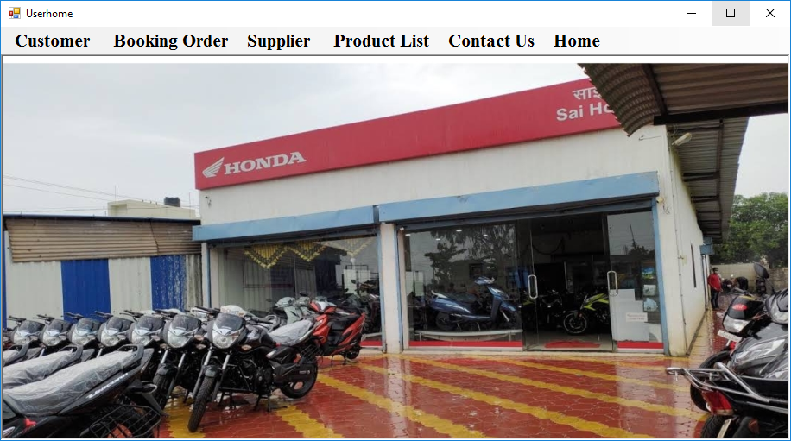

* **Customer:-**

**Customer Information:-**

**Submit:-**

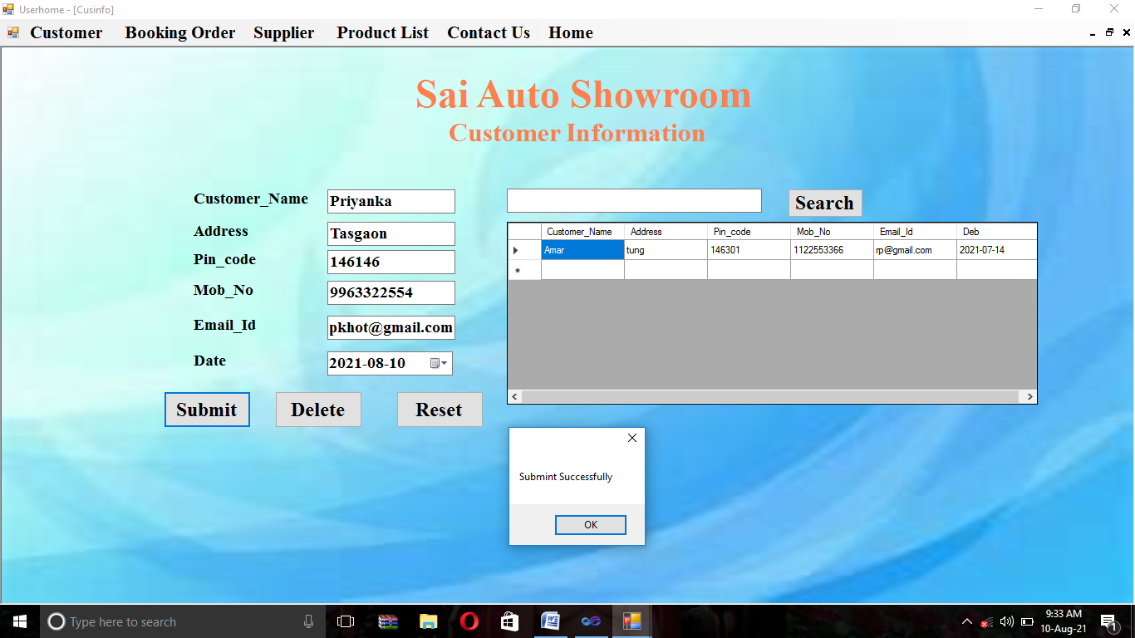

**Update:-**

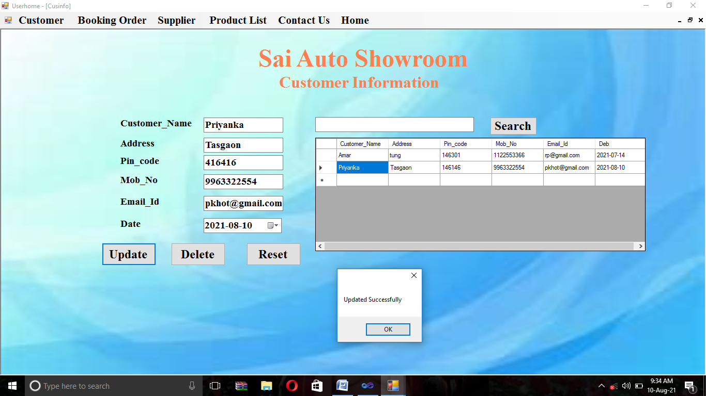

**Delete:-**

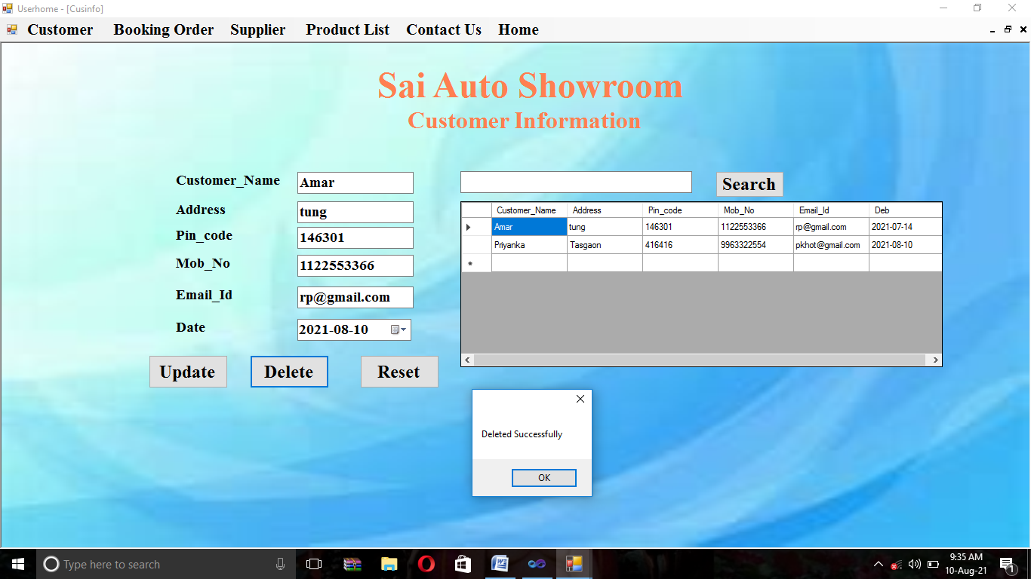

**Search:-**

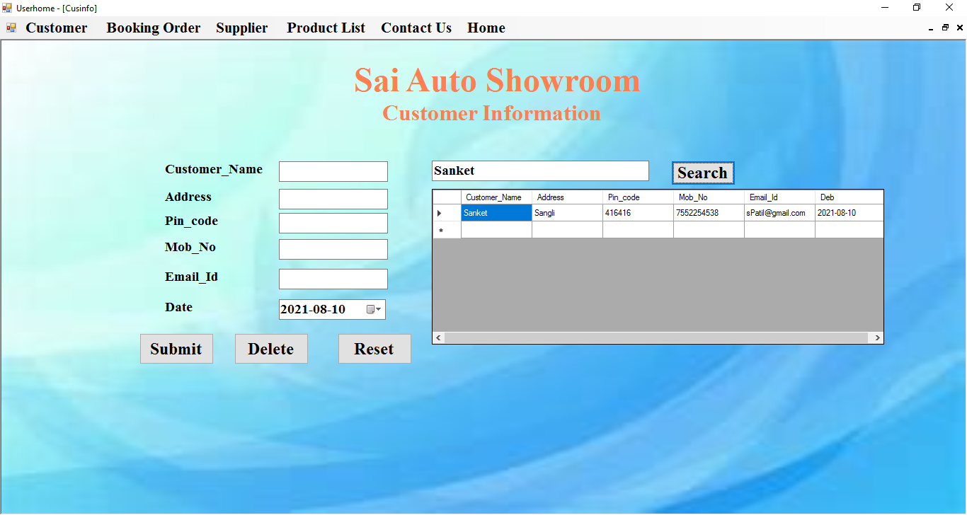

* **Customer Bill Form:-**

**Submit:-**

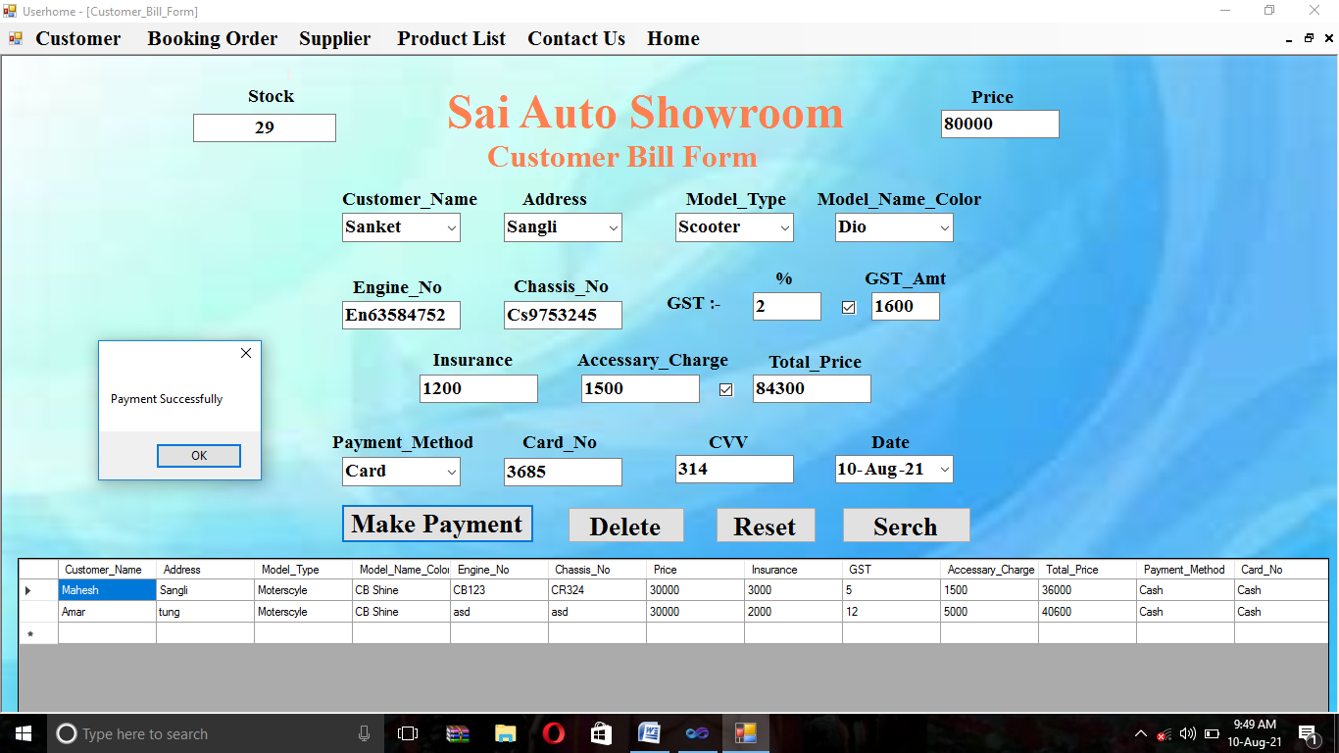

**Update:-**

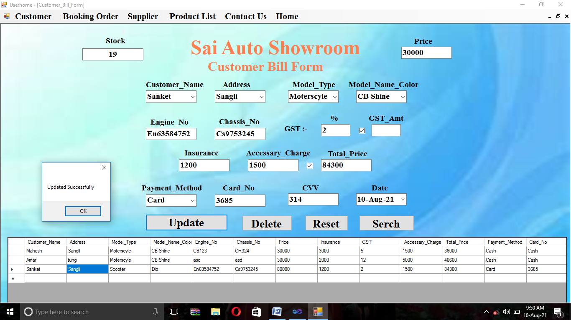

**Delete:-**

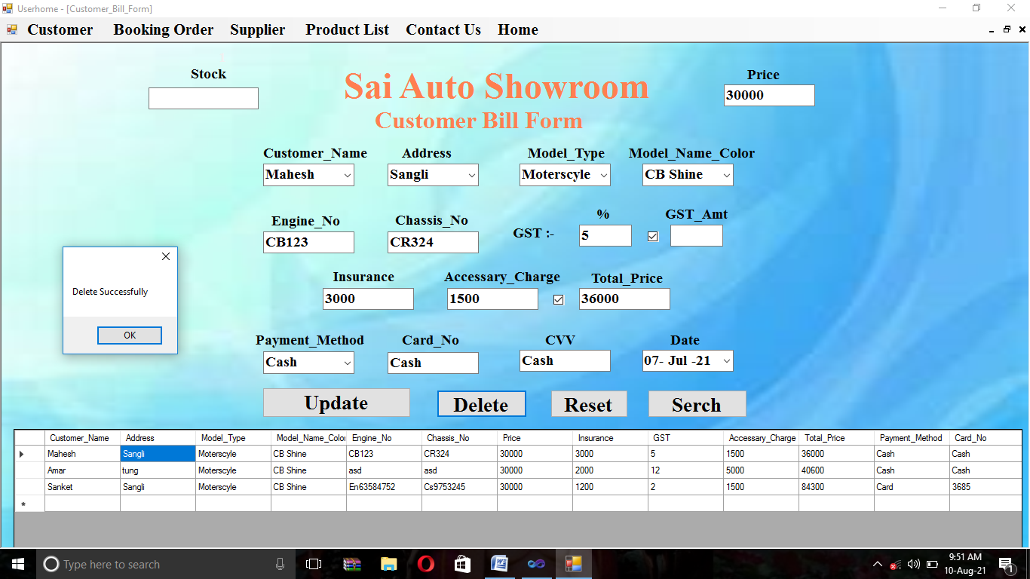

**Search:-**

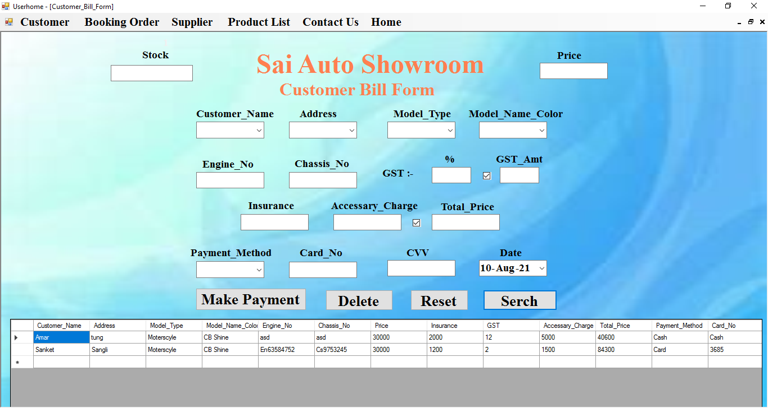

* **Booking Order:-**

**Submit:-**

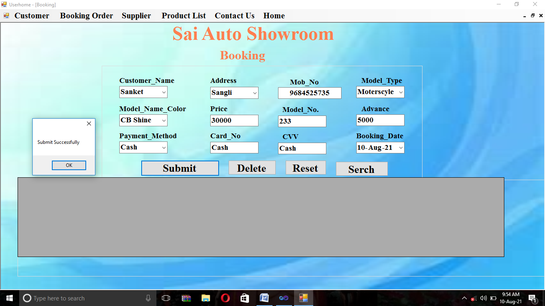

**Update:-**

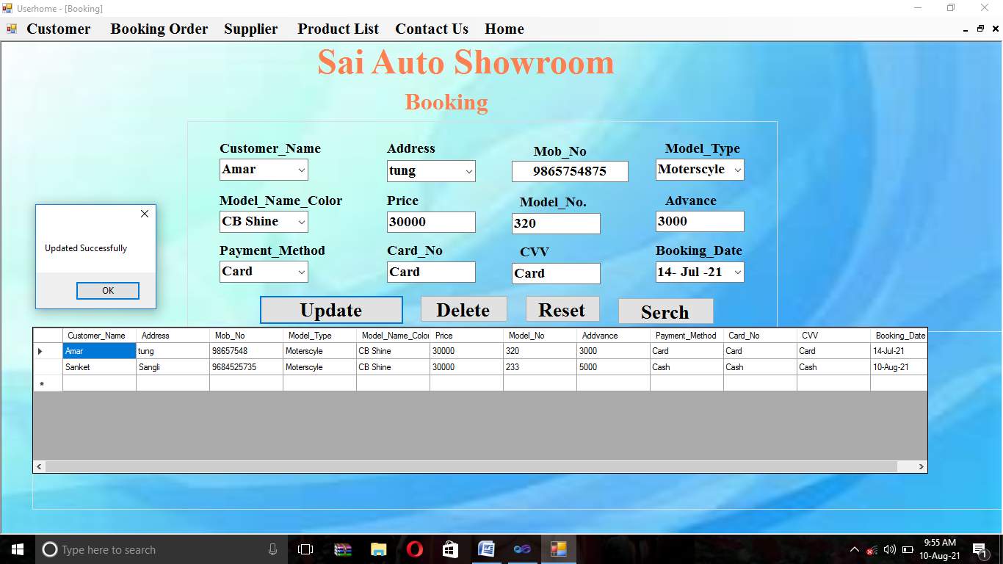

**Delete:-**

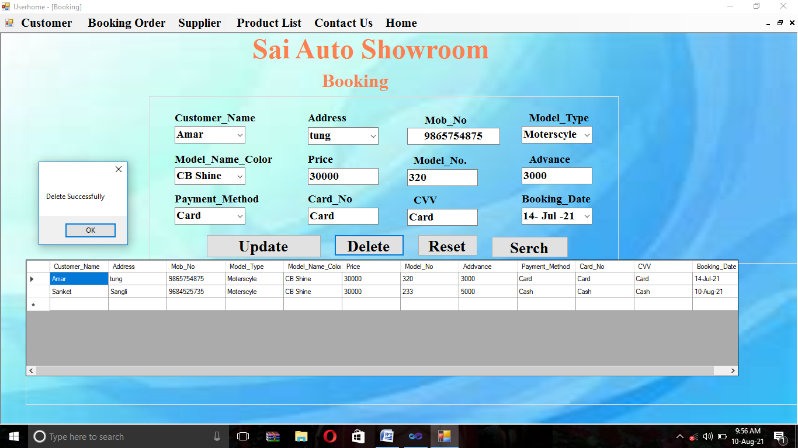

* **Supplier Bill Form**

**Submit:-**

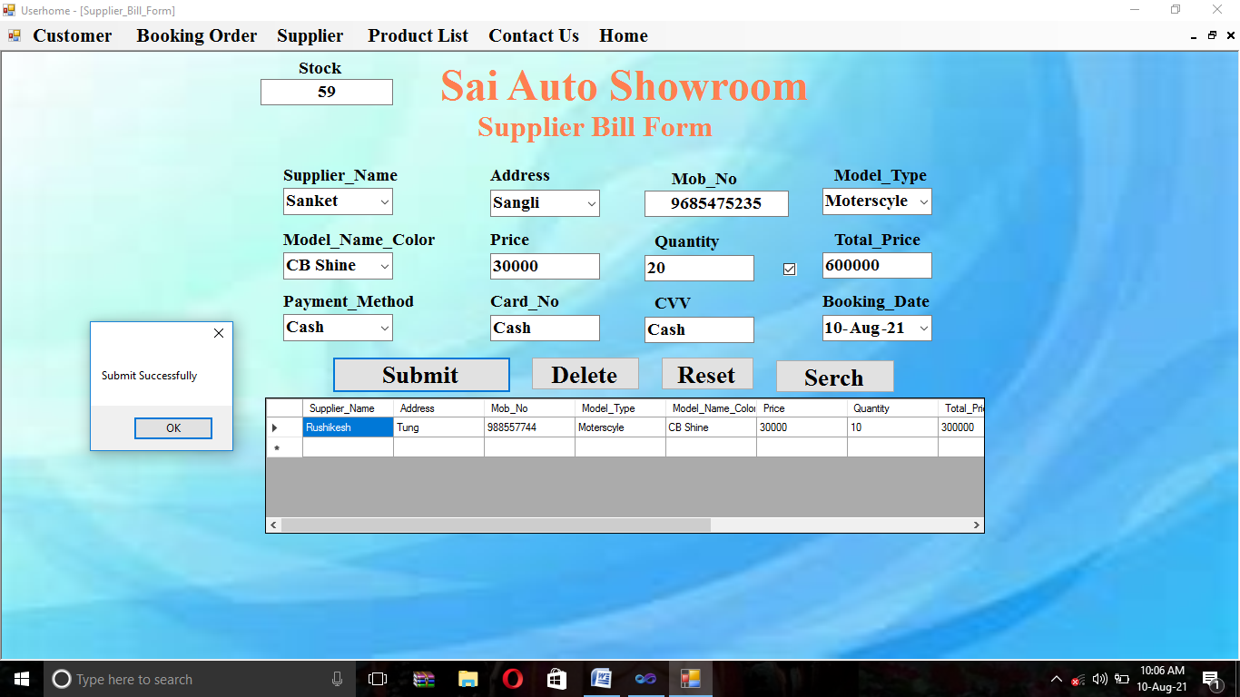

**Update:-**

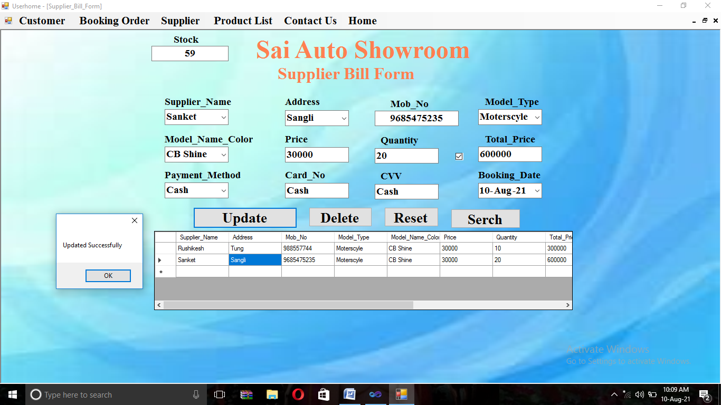

**Delete:-**

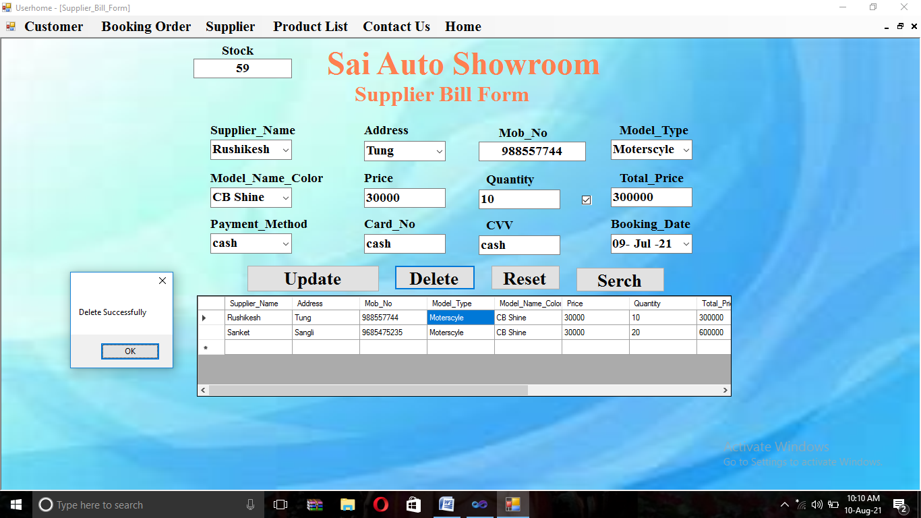

**Product List**

* **Motorcycle**

**XBlade:-**

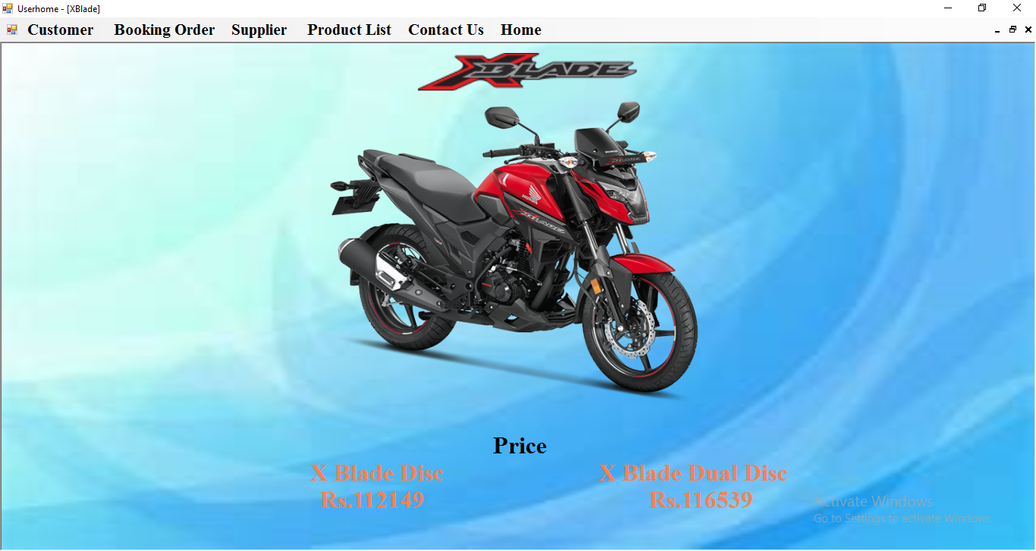

**CB Hornet:-**

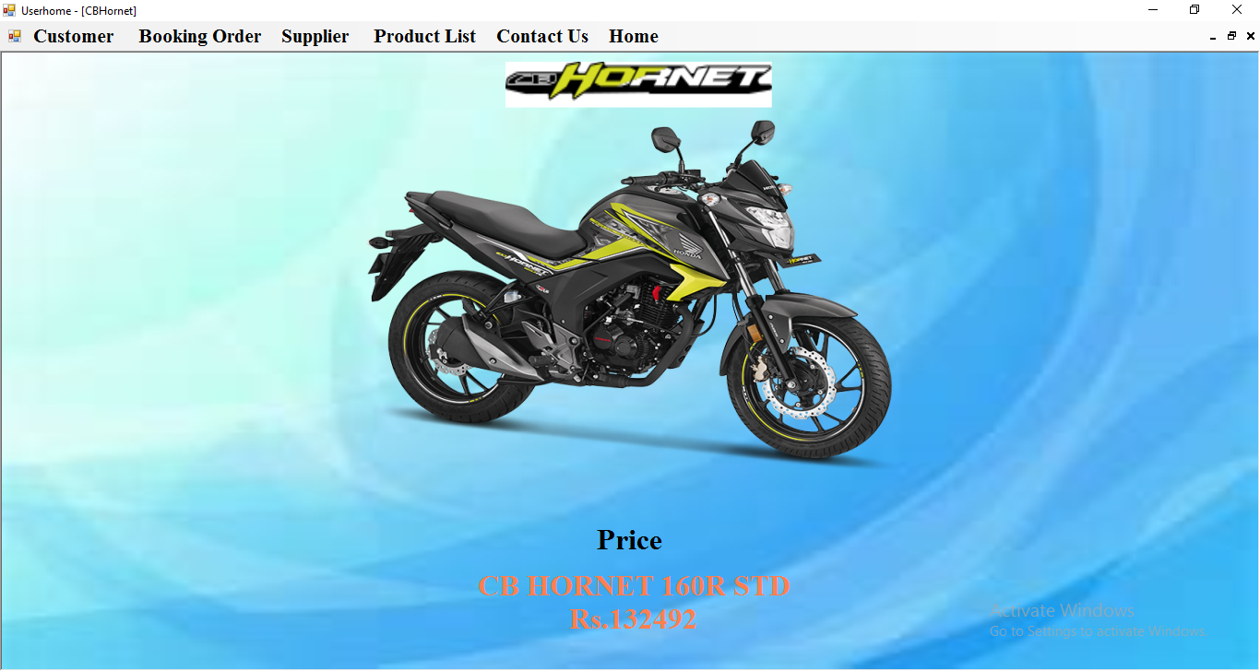

**CBR 250R:-** 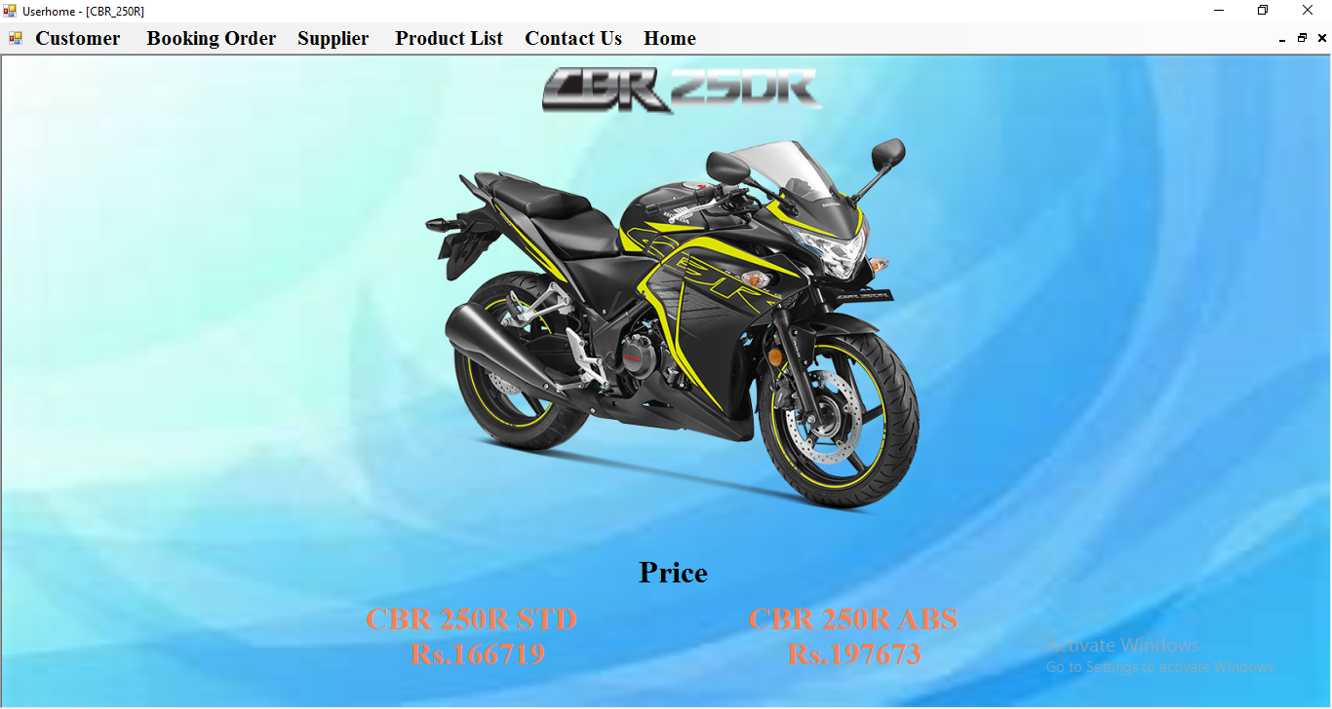

**CB Unicorn:-** 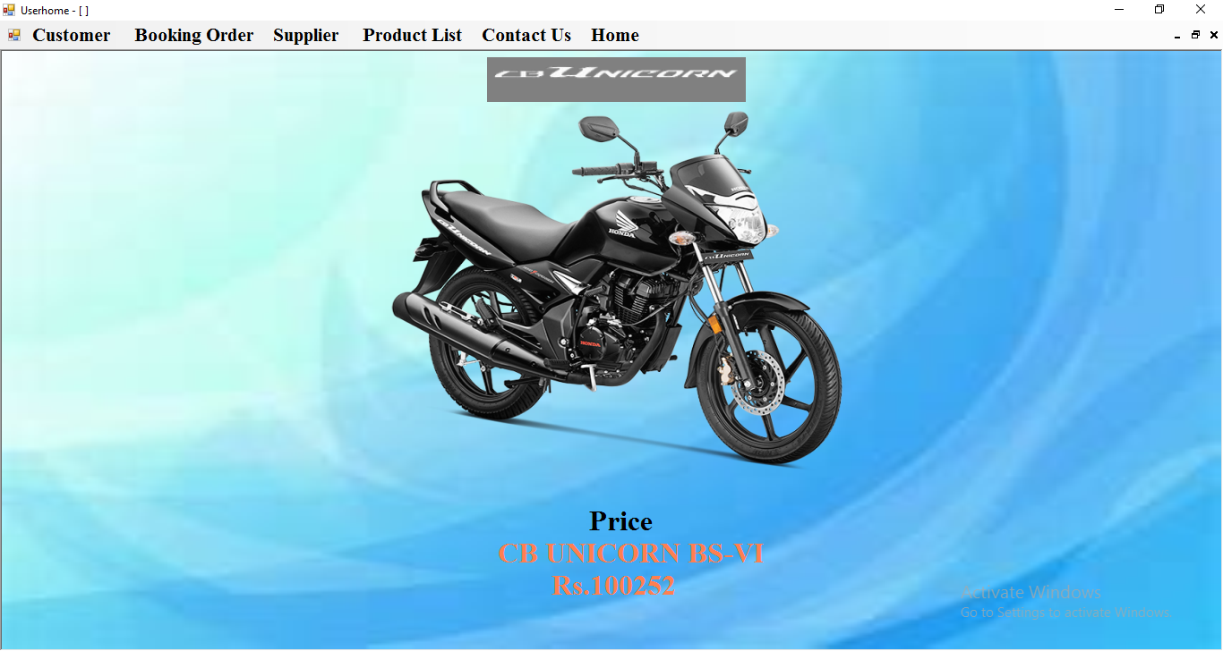

**SP125:-**

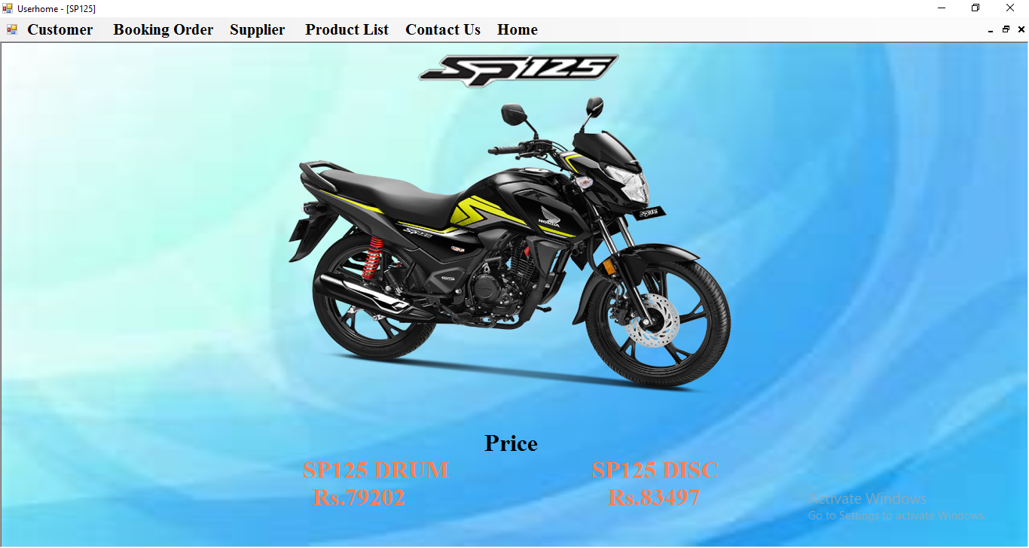

**CD110 Dream:-**

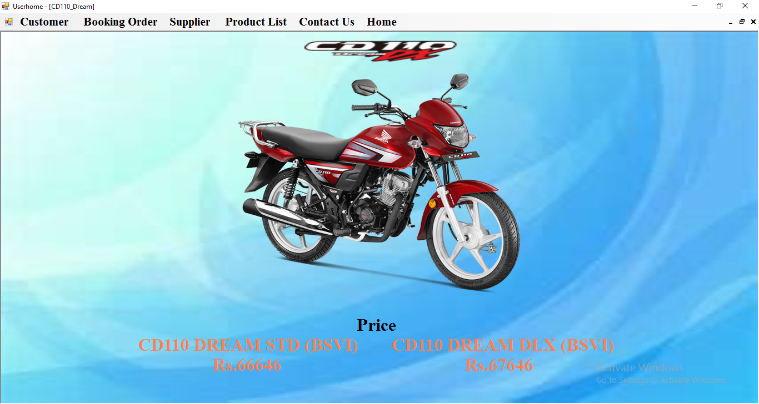

**Livo:-**

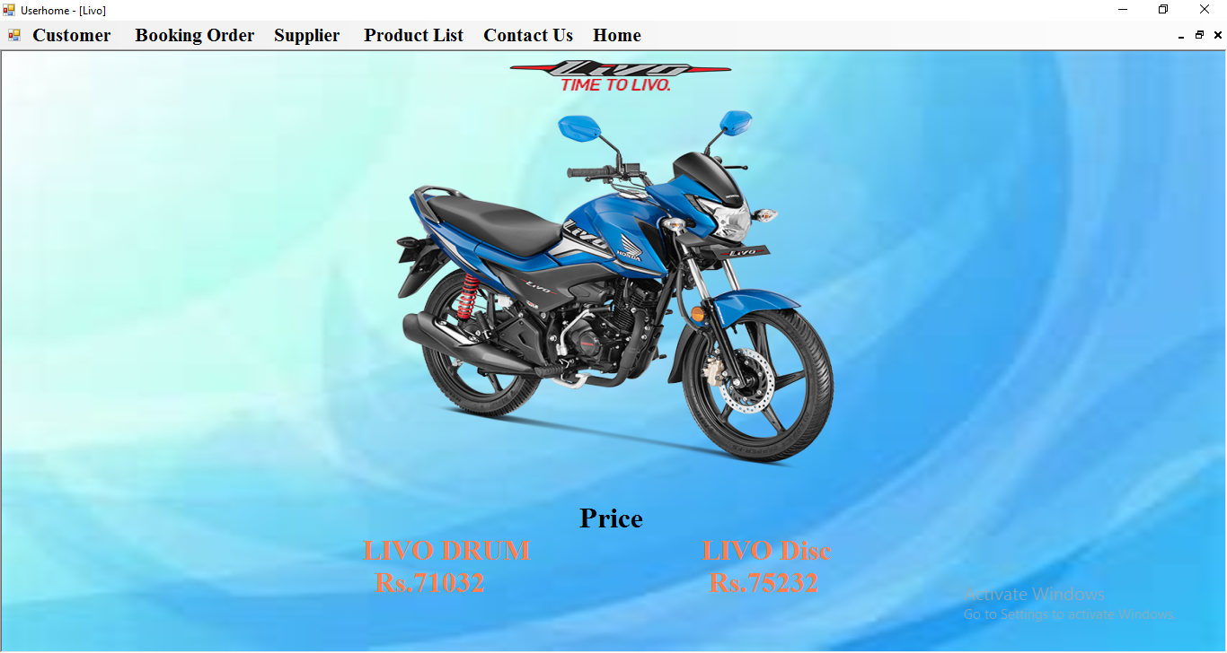

**CB Shine:-**

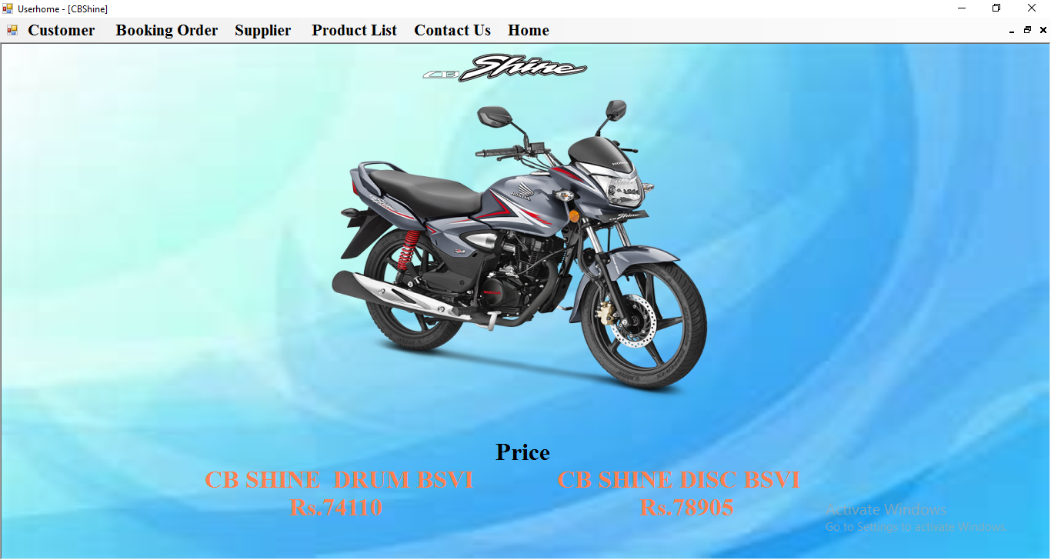

* **Scooter**

**Activa6G:-**

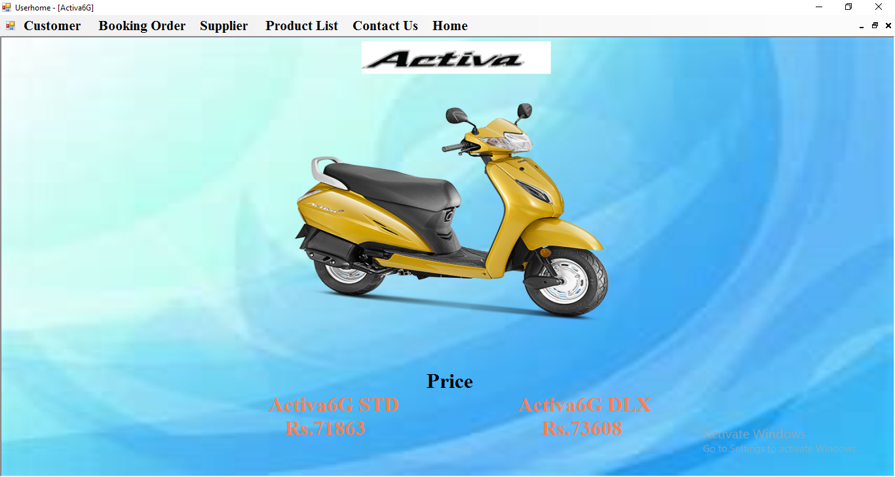

**Dio:-**

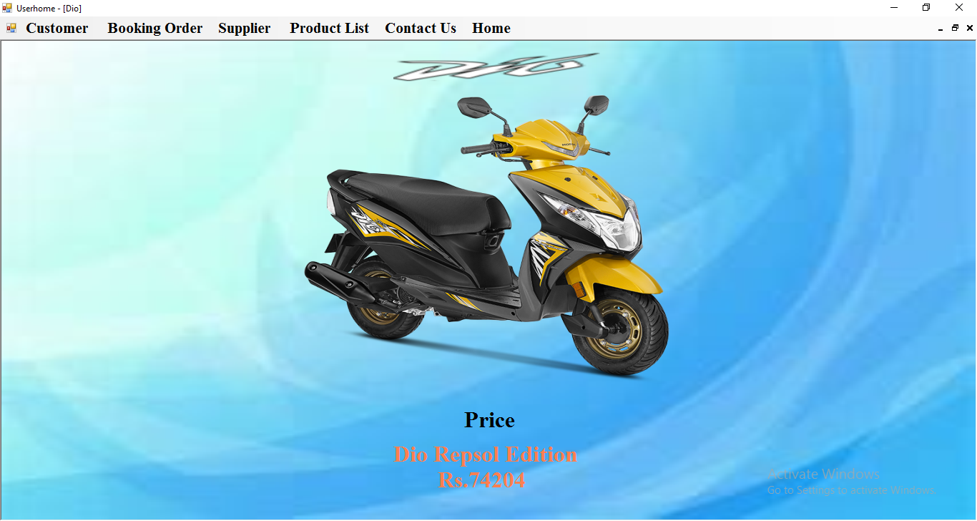

**Grazia:-** 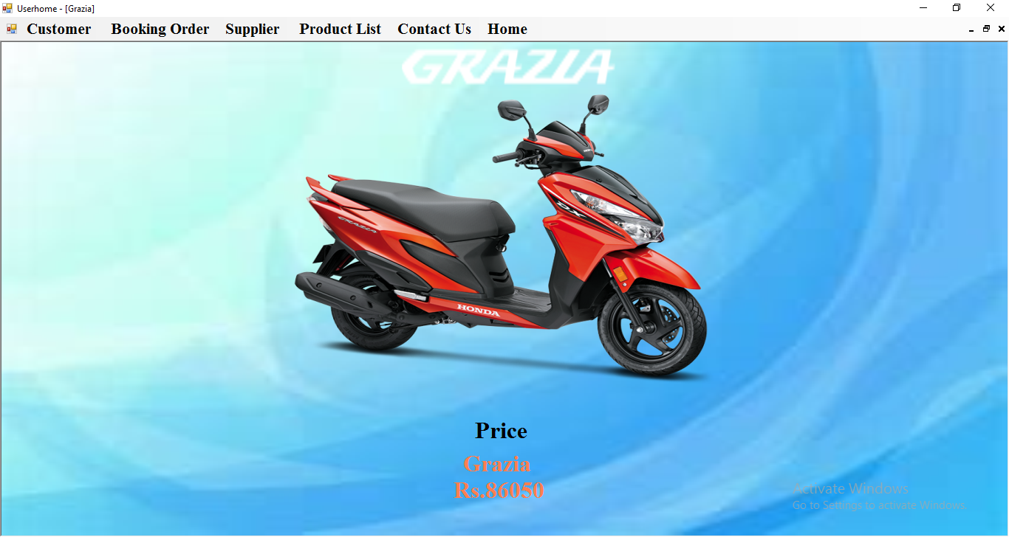

**Activa125:-** 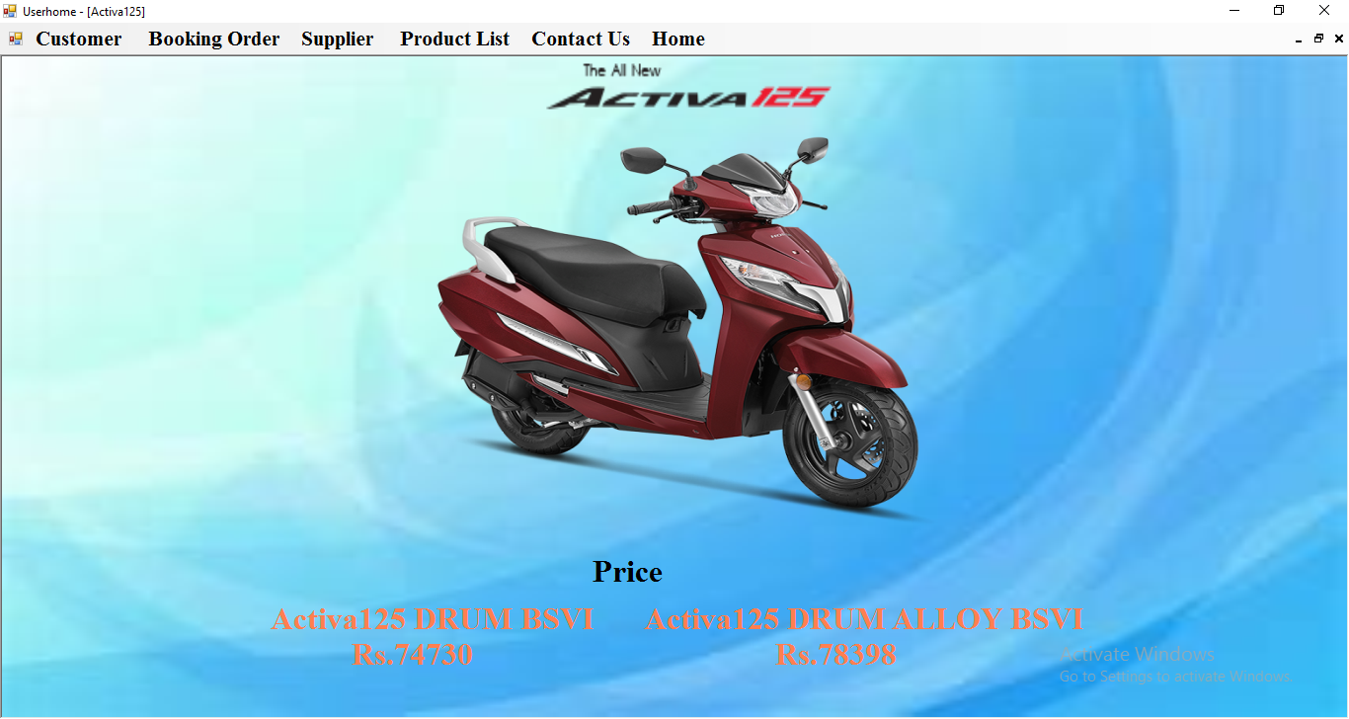

* **Super Bikes**

**AfricaTwin:-**

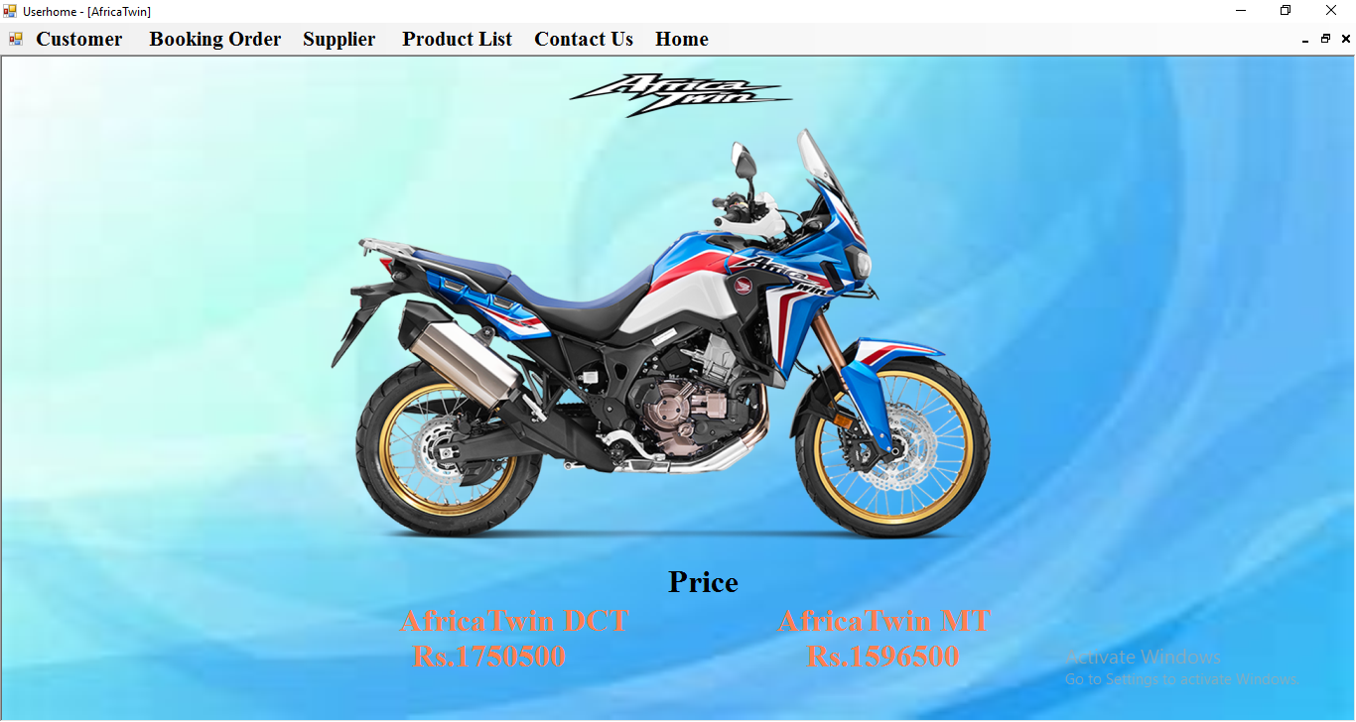

**CB1000R:-**

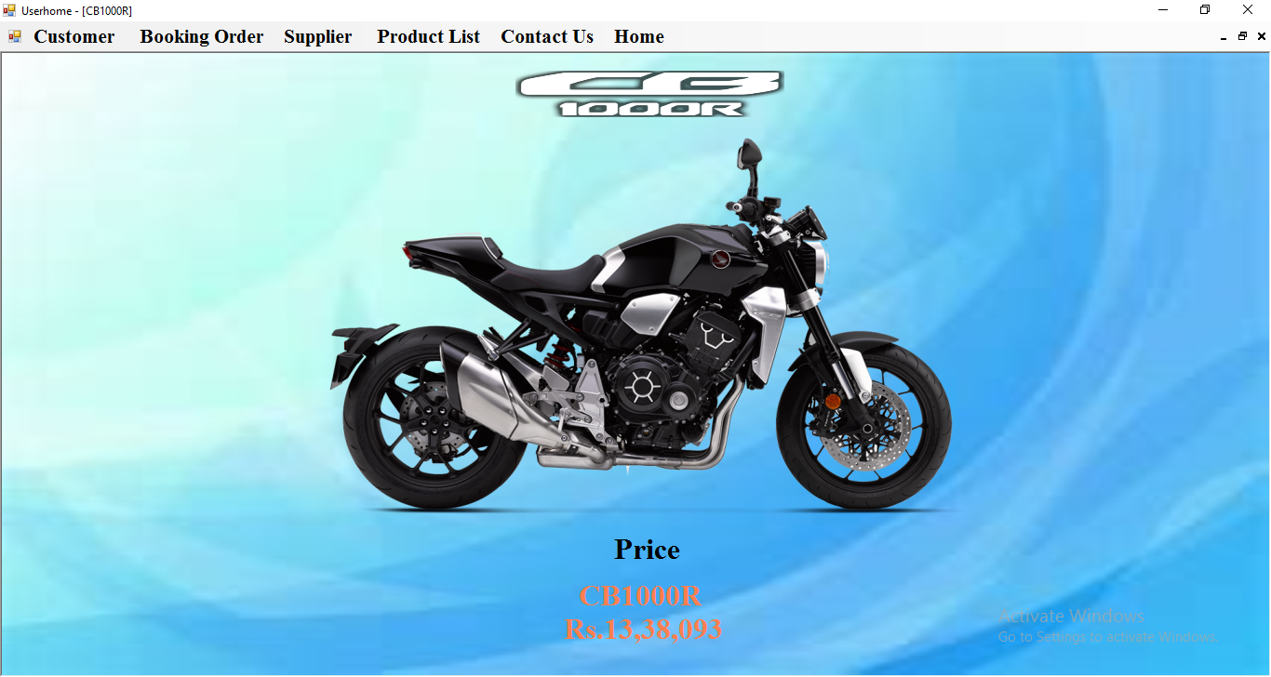

**CBR650R:-**

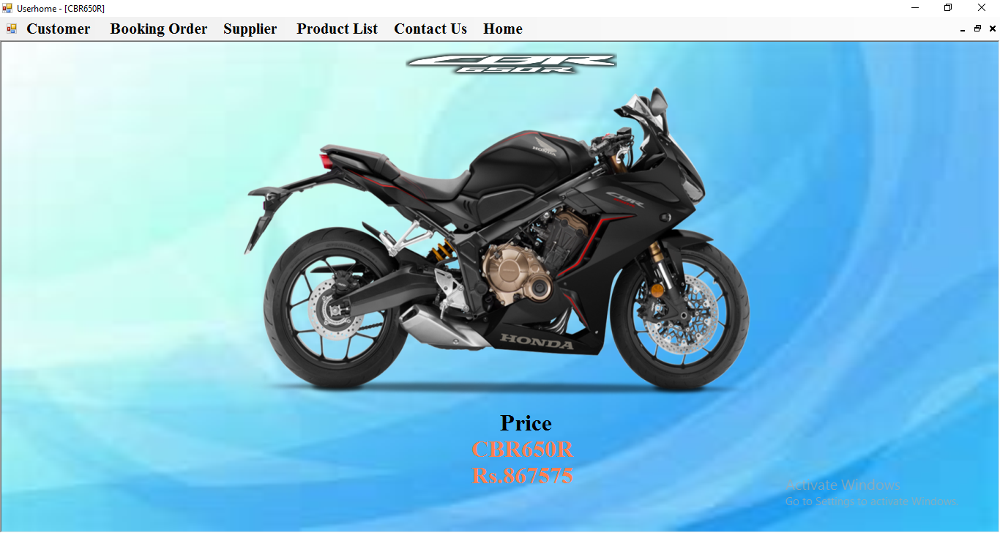

**CBR1000RR:-**

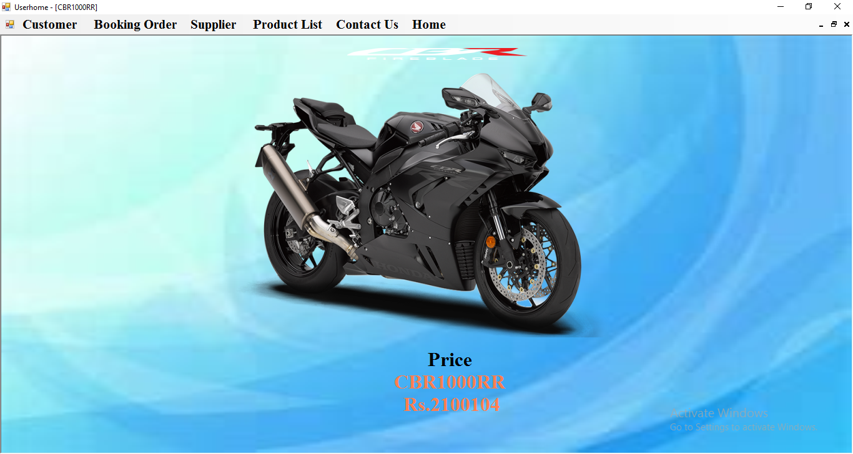

**GoldWing:-**

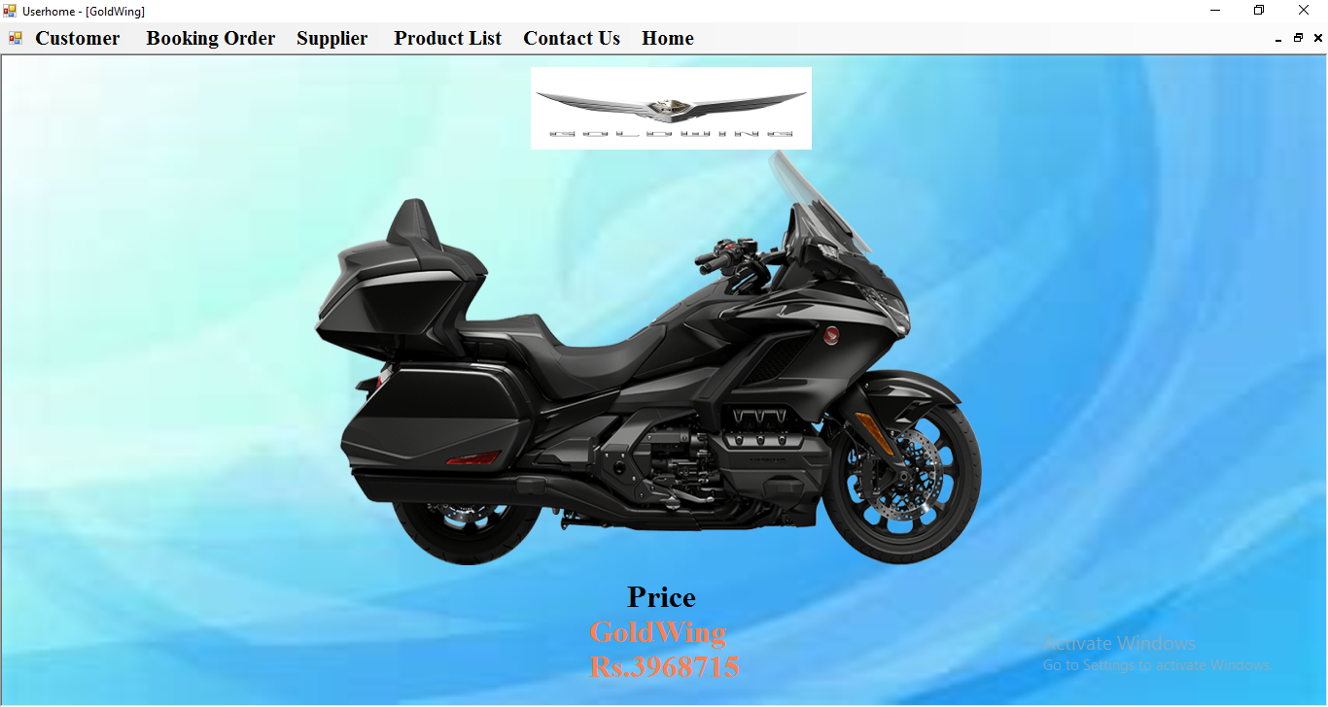

**SYSTEM REQUIREMENT**

* **HARDWARE REQUIRMENT**
* Processor :- Pentium II1 & above
* Ram :- 128 MB & above
* Hard disk :- Above 47 GB & above
* Monitor
* Keyboard
* Printer:
* Mouse
* **SOFTWARE REQUIRMENT**
* Windows 7 Operating System
* Visual Basic 6.0-Front End
* MS-Access 7 Back End with SQL

**CONCLUSION**

1. This project is basically server the purpose of dairy management system.

2. All the concerned with the dairy utilization are covered in this software project.

3. A large scale of database can be accommodating in this database making it easy to access the record.

4. This system reduces time & proper work, which helps to decrease complication and time.

5. Single person can manage the whole related independently by using the system.

**LIMITATION**

1. This software operates only single user.

2. Only computer literate can use this software.

3. This system is not multi user.

4. This system cannot work online. So there is no possibility to share data.

**SUGGESTION**

1. Only trained person means that has the knowledge to handle the system.

2. All fields must be filled out clearly by user.

3. The user should have authority to use this system. Unauthorized user cannot handle this system.

**BIBLIOGRAPHY**

**BOOKS:**

* VISUAL BASIC 10.0

PETER WRIGHT

* VISUAL BASIC 6.0 PROGRAMMING

HOLZER STEVEN

* SYSTEM ANALYSIS AND DISINE

AWARD F.H.

* VISUAL BASIC 6.0 PROGRAMMING BLACK BOOK

STEVEN HOLZNER

* MICROSOFT ACCESS-2003 DEVELOPET

BPB PUBLICATION

**WEBSITE:**

www.google.com